I have continuously owned RX7’s since 1980, used 1st gen (1980), new 2nd gen (1986), and a new 3rd gen (1994) since 1994. I first modified the 3rd gen back in 2004 and added the Apexi Power FC back in 2008 following an engine rebuild. I have had the car professionally tuned in 2008 and 2014. I have often, for many years, road tuned my car myself, following logging runs for cruise and boost, using the tuning notes from Chuck (cewrx7r1), the Exel programs from Barry Bordes and using the Datalogit FC-edit software. I have made prior adjustments to many of the settings for the turbos, injector transitions, and even acceleration enrichment through the years following recommendations from Chuck and Raymond (arghx), who did much of the early research. One thing that always remained allusive however is the ability of the old, out of date by modern ECU standards, Power FC to provide reasonable acceleration enrichment (AE) using the three tables in Settings 2, Accelerate Injector (mS), Inj vs Accel TPS1, and INJ vs TPS. Raymond posted many of his findings while adjusting these three tables back in 2009. He was able to improve acceleration somewhat with his recommended changes, which I have used over the past 5-6 years, but the acceleration enrichment (AE) problem was never truly solved for me and others. Recently, I have been working with Xavier Borg, a technical expert and a frequent member of the RX7 Yahoo tuning group, who has been able to help analyze the underlying code used by the Power FC.

Before discussing the tables, let me state that the discussions below are my opinion based on 20-25 hours of road testing with 30-40 hours of analysis to help figure these three tables out. I changed many of these settings dozens and dozens of time to eventually allow much more effective, non-lean acceleration in my own car. The changes in these tables, particularly the Accelerate Injector and the Inj vs Accel TPS1, are highly specific to my car. Others will likely need to use much less drastic changes to still achieve more effective acceleration results. I would also state that I am not an engineer or an automotive engineer, but a car enthusiast that happens to be a physician, a radiologist, and so bear with me if this doesn't read like a professional technical problem-solving manual.

Volumetric Efficiency (VE)
The one thing that is most important for this discussion of acceleration enrichment (AE) is the air flow modifications for the intake and exhaust highlighted below for my specific car as compared to a completely stock car. My extrude honed UIM/LIM increased my air flow by 40 % at 1 psi through the UIM/LIM as tested by the extrude honing company (this will be much less at higher pressure) and if you add up all of my other air flow changes, it is significant. The exact overall increased air flow efficiency or increased volumetric efficiency of my car is unknown, but it is likely much higher than many other street ported twin turbo rotaries. This increase in volumetric efficiency directly correlates to the need for additional fuel for acceleration enrichment to match the additional intake air used. The Apexi base map values for acceleration enrichment (AE) are suboptimal for most modified RX7’s in my opinion. Running a rotary lean during initial acceleration (poor torque) makes no sense for optimal acceleration as well as the engine stress. Just think that every time you accelerate from a stop sign or a traffic light or to merge on the highway, your car goes lean for the acceleration, which for me was 200-500 mSec. If you use the Apexi Power FC on a significantly modified RX7 and use the stock default values in the acceleration enrichment (AE) tables, I guarantee you it does. There simply is not enough extra fuel added. I just fixed that, I will tell you how, and I will explain every pertinent detail. First, the necessary background information and how each table works.

VERY IMPORTANT: YOU MUST USE THE DATALOGIT FC-EDIT SOFTWARE TO CHANGE THE INJ vs ACCEL TPS1 AND THE ACCELERATE INJECTOR TABLE VALUES!!! ONLY THE ACCELERATE INJECTOR VALUES CAN BE CHANGED WITH THE COMMANDER. DO NOT JUST CHANGE THE ACCELERATE INJECTOR VALUES WITHOUT CHANGING THE INJ vs ACCEL TPS1 VALUES TOO. YOU MUST EITHER BORROW A DATALOGIT OR HAVE SOMEONE UPLOAD YOUR UPDATED POWER FC .DAT FILE FOR YOU AFTER CHANGING THESE TABLE VALUES. THE COMMANDER ALONE WILL NOT WORK SINCE YOU CAN ONLY CHANGE THE ACCELERATE INJECTOR TABLE.

My major 1994 USDM Touring modifications pertinent to this discussion (bold most important):
-modified fuel basemap for the cruise region- AFR's set to low 15's in cruise region
-3mm apex seal street ported 13B- last rebuild in 2014
-Twin sequential Hitachi HT12-3KAI SP turbos
-Power FC with Datalogit with all table upgrades for IGN, injector transition, adjusted PIM, etc.
-Apexi 3 bar MAP sensor
-Fast AIT sensor still in stock location in UIM
-Post turbo EGT sensor and pre-IC temperature sensor
-ported exhaust and turbo manifolds, extrude honed UIM and LIM, RC ported throttle body
-SMB large bellow downpipe with at least 3” or more piping throughout with a RSR catback
-Vibrant racing metal cat rated for over 500rwhp
-dual bank U-type Australian SMIC
-Autoexe air intake (ram air) through Abflug scoop bumper with a 500cfm PWM controlled induction fan
-all intake and exhaust pipes, turbos, and IC are ceramic coated with either barrier or dispersant

Let’s go through the three acceleration enrichment (AE) tables, from least important to the two important ones, the least important being INJ vs TPS.
INJ vs TPS
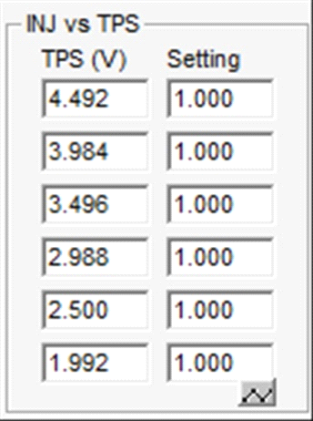
Stock 5-08 default map. I WOULD NOT CHANGE THIS TABLE!!
This table is pretty easy to understand, INJ vs TPS, which simply adds fuel based on the TPS signal from the gas pedal. The TPS voltage increases as the gas pedal is depressed. This has nothing to do with how fast the pedal is depressed but simply how far the pedal is depressed. Our typical TPS voltage is around 0.5V (rough average calibrated voltage) with the pedal at a neutral position (not pressed) and goes up to 4.4-4.6V at WOT or with the “pedal to the metal.” So, the value in the right column under Setting is simply the multiplier for the amount of acceleration enrichment (AE) fuel used. The unknown was when this table is used, always or only during acceleration enrichment (AE). Xavier Borg has believes that this table is used only during acceleration enrichment (AE) and not at other times. A setting of 1.00 in every row would mean no change in the fuel multiplier at any level through the entire gas pedal movement, as seen in this default map. If I changed the setting at 4.492V (WOT) to 1.07, then the Power FC would add 7% more fuel at this TPS voltage during acceleration enrichment (AE) and so on and so on. Raymond made some changes to this table many years ago due to his testing to improve acceleration, which I have used for several years. After concluding my testing, I did return back to the default table.

Let’s go through the next table, the first of the two important tables, Inj vs Accel TPS1. This table is directly related and dependent on, the Accelerate Injector, the other important table, which will be discussed last.

Inj vs Accel TPS1
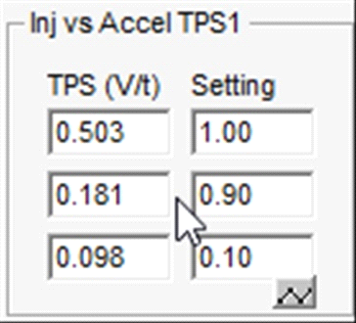
Stock 5-08 default map. THIS TABLE WILL BE CHANGED!!

This table adjusts the fuel added for acceleration from the other important table, Accelerate Injector, which will be discussed last. Any fuel added from the Accelerate Injector table is affected by this table according to how fast and how much gas pedal movement there is. The table that was first discussed, INJ vs TPS, could add more fuel based on the overall distance the gas pedal is depressed or the position of the gas pedal. This table will change the fuel added based on how fast and how much the gas pedal is depressed. The first column TPS (V/t) is the gas pedal movement based on how far, how fast, V/t (Volts per time). Despite all my testing, I could not determine for certain the exact amount of time used for the denominator. The problem in determining this for certain is that data logging through the Datalogit FC-edit is typically spaced at 30-50 mSec or more, which makes pinpointing the exact time reference difficult. Xavier Borg was able to determine from analyzing the underlying Power FC code that t=25mSec. Roughly from the numbers in the first column on the stock table, the 0.503 V/t is almost flooring it to actually flooring it (WOT or “pedal to the metal”). The 0.181 V/t is roughly a fast half throttle gas pedal movement, the typical gas pedal movement for brisk passing on the highway. The 0.098 is a more mild pedal movement, i.e. accelerating somewhat quickly from a stop or traffic light. Most of these values will be changed.

VERY IMPORTANT: The value entered in the Setting column, discussed next, can only use the first decimal place!!! This means only 1.0, 0.9, 0.8, 0.1, etc, can be entered. YOU CAN NOT ENTER A NUMBER INTO THE SECOND DECIMAL PLACE. Do not use values like 0.95, 0.88, 0.15, etc. with the Datalogit FC-edit software. THE POWER FC WILL NOT WORK RIGHT, WILL NOT RECOGNIZE THIS VALUE APPROPRIATELY, AND YOU WILL GO LEAN, SOMETIMES VERY LEAN, AT THE CORRESPONDING TPS (V/t) SETTING. I KNOW THIS FOR SURE FROM MY TESTING.

The second column or Setting is very similar to second column or Setting in the first table or INJ vs TPS. This is the fuel multiplier for the pedal movement in the first column or TPS (V/t). 1.00 means 100%. 0.90 means 90%, 0.10 means 10%. That's it, it is quite simple. The ideal values here however are highly dependent on the TPS (V/t) value used and the Accelerate Injector values in the last table, which I will explain later.

Let’s go through the last table, the important Accelerate Injector. This table is directly related to the Inj vs Accel TPS1, the table above, which I just discussed.

Accelerate Injector
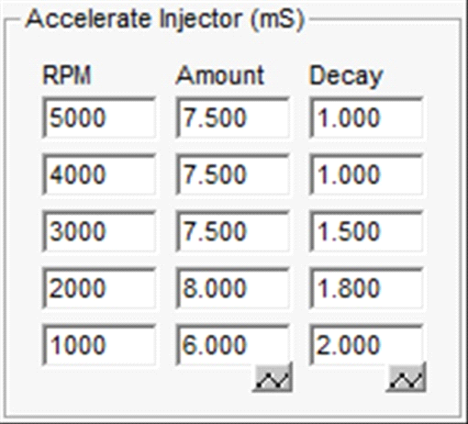
Stock 5-08 default map. THIS TABLE WILL BE CHANGED!!

This table was the most difficult to figure out. I have done 60-80 testing runs, searched the internet for hours on our forum and other car forums which also use the Power FC, crunched thousands of numbers, and theorized dozens of false and then true theories through the different testing days. I have, I believe, figured out this out with a 95% surety. This was subsequently confirmed by Xavier Borg. Now, let’s dive into it.

The first column is the RPM from which you begin accelerating. I have assumed that when in between the listed RPM’s values, the Power FC averages the Amount and Decay values, very similar to the fuel basemap tables for RPM vs. PIM (boost). In example, if you start accelerating at 2500 rpm, the stock value of 8.000 at 2000 rpm will be averaged with the value of 7.500 or the table’s Amount for 3000 rpm. The other possibility is the nearest values to the acceleration RPM are simply used. I don’t know for sure. Just know that some averaging may occur for in between RPM’s. Leave all of the values for RPM's alone.

VERY IMPORTANT: The values entered in the Amount and Decay columns, discussed next, can only use the first decimal place!!! This means only 10.5, 0.9, 0.8, 0.2, etc, can be entered. YOU CAN NOT ENTER A NUMBER INTO THE SECOND DECIMAL PLACE. Do not use values like 10.55, 0.88, 0.15, etc. with the Datalogit FC-edit software. THE POWER FC WILL NOT WORK RIGHT, WILL NOT RECOGNIZE THESE VALUES APPROPRIATELY, AND YOU WILL GO LEAN, SOMETIMES VERY LEAN. I KNOW THIS FOR SURE FROM MY TESTING.

Now let’s move on to Amount and Decay. This again took quite a long time to figure out and additionally, how to make these values work well. First, what do they relate to and how are they used. Many on this forum and other forums have theorized what these relate to and the relationship between them. The whole time, the basic meaning and relationship, was given in the instructions for the Datalogit FC-edit. Here it is in print.

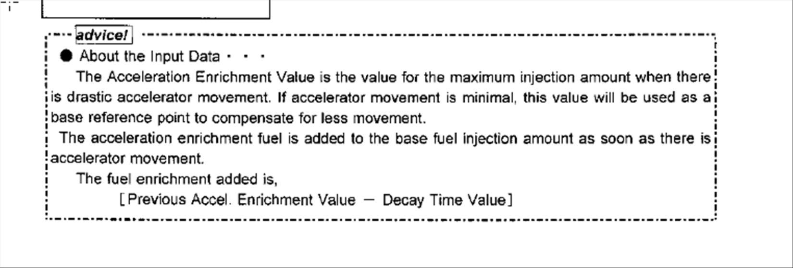
Simply put, when you accelerate, the Amount value in mSec is added to the overall fuel injector on time (mSec) or base fuel injection amount calculated by the Power FC using the fuel basemap for RPM-PIM (boost) which is also adjusted by other relevant tables within the Power FC program. The next time the fuel injector is cycled on, or on the next full rotor rotation, the amount of added injector on time (mSec) is the value in the table under Amount. In example, if the value is 7.500 mSec at 3000 rpm, then 7.500 mSec of additional fuel injector on time (mSec) is added on the first cycle following the acceleration. The next time the fuel injector is on, or on the next full rotor rotation, the amount of additional injector on time (mSec) is reduced by the Decay value. This continues to cycle until all the added fuel is gone. Let’s go through a basic example from the stock default table. If you accelerate from 3000 rpm on the stock table, then the next full rotor rotation, the Power FC will add 7.500 mSec of injector on time. The next full rotor rotation, the Power FC will add 6.000 mSec of additional injector on time (7.500 mSec- 1.5 mSec Decay). The next full rotor rotation, 4.500 mSec of additional injector on time (6.000 mSec- 1.5 mSec Decay) will be added, and so on and so on until all the additional injector on time or additional fuel is gone. In this example, that is only in 3 more cycles or 3 full rotor rotations. That is the basic concept. This is a simple linear decay model, in this case a stair step linear decay. The Decay value simply determines how steep the slope of decay is and the Amount value is how high the peak is at the starting point. Xavier Borg recently determined this Amount of additional fuel is divided between both rotors’ fuel injectors, 1/2 to the front and 1/2 to the back injectors. The overall principle remains the same, however.

Stair step linear decay
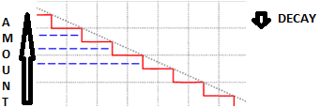

Now let’s bring back in the table, Inj vs Accel TPS1, from before. The Setting values in that table are simply the multiplier for the Amount values in this table depending on corresponding gas pedal movement or TPS (V/t) value. If the car is floored (WOT) or "pedal to the metal" or a TPS (V/t) value greater than 0.503 from that table, then the added injector on time Amount value is used without change Setting 1.00 (100%) during this brisk acceleration for that respective RPM. If the gas pedal is moved according to the second row Setting in the Inj vs Accel TPS1 table, then the added injector on time Amount values are multiplied by 0.90 or are used at 90% at that respective RPM. If more mild pedal movement is made from the third row of this table, then only 0.10 or 10% of the added injector on time Amount value is used at that respective RPM. That’s it, fairly simple.

Now to why the stock default values in the tables, Accelerate Injector and Inj vs Accel TPS1, are grossly inadequate for my car, very likely inadequate for almost all modified cars, and how to fix it.

Let me show you two logs that I have made through the Datalogit using the FC-Edit software. First, let’s look at a log from back in 2014, before my recent rebuild. That car had only a few air flow mods at that time. It was street ported, twin sequential, Greddy SMIC, a Bonez downpipe, and a Bonez high flow cat. I basically used the stock default acceleration enrichment (AE) table values back then and I did not adjust my fuel basemap for cruise.

[13B-REW v5.08]
Time(S) | AN1 raw | AN2 raw | AN3 raw | AN4 raw | AN1-AN2 Wide Band | AN2 raw | AN3 raw | AN4 raw | MAPN | MAPP
13.141 | 1.980 | 0.020 | 0.059 | 0.059 | 13.654 | 0.020 | 0.059 | 0.059 | 6 | 4
13.235 | 1.941 | 0.000 | 0.059 | 0.059 | 13.613 | 0.000 | 0.059 | 0.059 | 6 | 5
13.375 | 1.941 | 0.000 | 0.059 | 0.059 | 13.613 | 0.000 | 0.059 | 0.059 | 6 | 5
13.469 | 1.922 | 0.000 | 0.059 | 0.059 | 13.572 | 0.000 | 0.059 | 0.059 | 6 | 6
14.610 | 2.667 | 0.000 | 0.059 | 0.059 | 15.128 | 0.000 | 0.059 | 0.059 | 6 | 6
14.703 | 2.863 | 0.000 | 0.059 | 0.059 | 15.537 | 0.000 | 0.059 | 0.059 | 6 | 6
14.797 | 3.000 | 0.020 | 0.059 | 0.059 | 15.783 | 0.020 | 0.059 | 0.059 | 6 | 7
14.891 | 2.922 | 0.000 | 0.059 | 0.059 | 15.660 | 0.000 | 0.059 | 0.059 | 7 | 7
14.922 | 2.765 | 0.000 | 0.059 | 0.059 | 15.333 | 0.000 | 0.059 | 0.059 | 7 | 7
15.000 | 2.627 | 0.000 | 0.059 | 0.059 | 15.046 | 0.000 | 0.059 | 0.059 | 7 | 7
15.110 | 2.529 | 0.020 | 0.059 | 0.059 | 14.800 | 0.020 | 0.059 | 0.059 | 7 | 8
15.156 | 2.431 | 0.000 | 0.059 | 0.059 | 14.637 | 0.000 | 0.059 | 0.059 | 7 | 8
15.281 | 2.333 | 0.020 | 0.059 | 0.059 | 14.391 | 0.020 | 0.059 | 0.059 | 7 | 8
15.375 | 2.118 | 0.000 | 0.059 | 0.059 | 13.982 | 0.000 | 0.059 | 0.059 | 7 | 8
15.453 | 2.000 | 0.020 | 0.059 | 0.059 | 13.695 | 0.020 | 0.059 | 0.059 | 7 | 9
15.610 | 1.961 | 0.000 | 0.059 | 0.059 | 13.654 | 0.000 | 0.059 | 0.059 | 8 | 9
15.703 | 1.843 | 0.000 | 0.059 | 0.059 | 13.408 | 0.000 | 0.059 | 0.059 | 8 | 9
15.797 | 1.863 | 0.020 | 0.059 | 0.059 | 13.408 | 0.020 | 0.059 | 0.059 | 8 | 9
15.860 | 1.784 | 0.020 | 0.059 | 0.059 | 13.245 | 0.020 | 0.059 | 0.059 | 8 | 10
15.906 | 1.961 | 0.020 | 0.059 | 0.059 | 13.613 | 0.020 | 0.059 | 0.059 | 8 | 10
16.016 | 1.902 | 0.020 | 0.059 | 0.059 | 13.490 | 0.020 | 0.059 | 0.059 | 9 | 10
16.141 | 1.824 | 0.000 | 0.059 | 0.059 | 13.368 | 0.000 | 0.059 | 0.059 | 9 | 10
16.266 | 1.784 | 0.020 | 0.059 | 0.059 | 13.245 | 0.020 | 0.059 | 0.059 | 9 | 10
16.360 | 1.745 | 0.000 | 0.059 | 0.059 | 13.204 | 0.000 | 0.059 | 0.059 | 9 | 10

This was a mid level slower acceleration, likely in the second row for stock default table Inj vs Accel TPS1, which would mean 90% of table Accelerate Injector was used. The starting RPM was around 2600-2800 and the car went lean at time 14.610 sec with an AFR of 15.128 and stayed lean until after time 15.375 sec when the AFR dropped below 14. This was only with mild acceleration and with a lightly modified car at that time. This is not a dramatic lean event, but none the less, not ideal either.

Now if you want to see dramatic lean events, let’s look at my car after the recent rebuild while still using the stock default tables but also using a fuel basemap setup for cruise, which means I start most accelerations in higher AFR (cruise cells). The lean events were so bad using the stock Accelerate Injector table values (or when using even lower values in my early testing logging runs I tried while trying to correct my lean accelerations) that I was having lean misfires that rocked the car so badly that I thought my engine was a goner on several occasions. These misfires were still in mild vacuum or early low boost and that is the only reason the engine still runs today. Here is a typical example of a lean acceleration from a logging run at 3000 rpm in third gear using the stock values for the Accelerate Injector and Inj vs Accel TPS1 tables. Note the higher knock going into boost after the lean areas.

[13B-REW v5.08]
Time(S) | InjDuty | Rpm | Boost | Knock | AN1 raw | AN2 raw | AN3 raw | AN4 raw | AN1 AFR
1.797 | 12.0 | 2908 | -473 | 31 | 2.490 | 2.078 | 2.137 | 0.098 | 14.882
1.875 | 12.0 | 2908 | -471 | 19 | 2.490 | 2.078 | 2.098 | 0.078 | 14.760
1.985 | 12.0 | 2904 | -471 | 21 | 2.549 | 2.059 | 2.098 | 0.078 | 14.882
2.110 | 12.0 | 2905 | -471 | 32 | 2.490 | 2.078 | 2.098 | 0.078 | 14.800
2.219 | 11.9 | 2894 | -472 | 33 | 2.549 | 2.078 | 2.098 | 0.078 | 14.964
2.329 | 11.9 | 2891 | -473 | 33 | 2.510 | 2.078 | 2.098 | 0.078 | 14.923
2.407 | 11.9 | 2899 | -473 | 33 | 2.588 | 2.078 | 1.98 | 0.078 | 15.087
2.500 | 11.9 | 2894 | -468 | 22 | 2.569 | 2.078 | 2.118 | 0.078 | 16.111
2.610 | 11.9 | 2893 | -460 | 31 | 2.647 | 2.078 | 2.118 | 0.078 | 17.544
2.750 | 12.9 | 2909 | -424 | 30 | 3.137 | 2.059 | 2.098 | 0.078 | 20.000
2.860 | 20.1 | 2837 | -242 | 23 | 3.824 | 2.078 | 2.118 | 0.078 | 20.000
2.938 | 29.9 | 2935 | -82 | 33 | 5.000 | 2.059 | 2.118 | 0.078 | 15.783
3.016 | 39.4 | 3030 | 1 | 46 | 5.000 | 2.098 | 2.118 | 0.078 | 15.005
3.110 | 39.2 | 2869 | 9 | 49 | 2.980 | 2.098 | 2.118 | 0.078 | 14.882
3.204 | 46.9 | 2991 | 17 | 36 | 2.608 | 2.118 | 2.118 | 0.078 | 13.449
3.266 | 48.6 | 2930 | 24 | 39 | 2.549 | 2.137 | 2.137 | 0.078 | 13.572
3.407 | 48.2 | 2980 | 37 | 27 | 1.863 | 2.078 | 2.098 | 0.078 | 13.736
3.500 | 48.5 | 3088 | 44 | 32 | 1.922 | 2.098 | 2.176 | 0.078 | 13.408
3.610 | 48.5 | 3078 | 53 | 32 | 2.000 | 2.059 | 2.196 | 0.078 | 12.917
3.704 | 48.6 | 3126 | 57 | 36 | 1.843 | 2.039 | 2.196 | 0.078 | 11.853
3.766 | 48.6 | 3156 | 59 | 36 | 1.608 | 2.02 | 2.216 | 0.078 | 11.402
AFR adjusted log for O2 sensor delay.

If you think AFR’s above 15 or near 16 are bad, try an AFR of 20 for around 200 mSec. This is not an isolated event; I had dozens of runs with AFR’s in the 18’s or 19’s or yes, even 20 using the stock tables. Now you can see why I had to fix this lean acceleration problem. Your acceleration is horrible at 20 AFR, you should believe me on that one. To answer many of you who will question that there is something else wrong with car, such as the fuel pressure, injectors, Power FC, wiring harness, etc., all of these were either changed, verified functioning within spec, or are brand new. The Power FC was changed during testing to a new one and did not affect the acceleration problem but did fix an injector transition problem. I even added a new Hypervoltage power buffering system and a Hyperground system with eight new grounds to improve ECU and sensor voltage and overall power stability.

IMPORTANT: YOU SHOULD HAVE A FULLY FUNCTIONAL, NEAR IDEAL, FUEL BASEMAP IN PLACE BEFORE CHANGING ANY OF THESE TABLES. IF YOU ARE TOO RICH ANYWHERE OR TOO LEAN ANYWHERE IN THE MAP, THESE CHANGES WILL EXENUATE RICH CONDITIONS AND MASK LEAN CONDITIONS DURING ACCELERATIONS. FIX YOUR FUEL BASEMAP FIRST!!!! IF YOU USE A CRUISE FUEL BASEMPAP SETUP LIKE I DO, YOU ARE UNFORUTNATELY ACTUALLY STARTING MOST ACCELERTATIONS FROM A LEAN AREA, WHICH COMPLICATES THINGS EVEN FURTHER.

IMPORTANT: YOU SHOULD HAVE YOUR INJECTOR TRANSITION IN SETTINGS 5 WORKED OUT FOR SMOOTH PRIMARY TO SECONDARY TRANSITION. FOR MY STOCK RC550cc PRIMARIES AND ID2200cc SECONDARIES, THIS MEANS A PRI/SEC TRANSITION % of 30.0 AND A SEC TRANSITION of 0.10mSec WITH LAG VALUES OF 0.24 FOR BOTH THE FRONT AND REAR SECONDARIES.

Now the fix for Accelerate Injector and Inj vs Accel TPS1!!! All of these changes discussed below are dependent on changing both of these important acceleration enrichment (AE) tables in unison or at the same time before testing or using. DO NOT MAKE ONE VALUE CHANGE OR ONE TABLE CHANGE AND EXPECT GOOD RESULTS. THESE TABLE VALUES ARE AGAIN HIGHLY DEPENDENT UPON AND INTERRELATED TO EACH OTHER. ONCE ALL THE INITIAL CHANGES ARE MADE TO BOTH TABLES AND ALL NECESSARY NEW VALUES ARE INPUTTED, YOU THEN CAN AND MAY WANT TO CHANGE INDIVIDUAL VALUES TO FINE TUNE THE RESULTS LATER AFTER TESTING.

Inj vs Accel TPS1
The first row stock TPS value of 0.503 you could leave alone. I did decrease the value to 0.400, which for my car seemed to work best to fine tune my acceleration in the higher RPM’s. For most mildly modified cars, I would either leave it alone or decrease the value to around 0.449. The second row stock TPS value of 0.181 is grossly inadequate for me. I found I needed more acceleration fuel sooner with something around a 1/3 throttle pedal push. I was going very lean with moderate pedal movement such as during quick passing. Through a lot of testing, I eventually lowered the TPS value to 0.122 and found it best. More fuel sooner. Get this right, and quick passing is quite fun. For most cars, I would start around 0.151 and go a little lower if necessary. The last row stock TPS value of 0.098 I also found grossly inadequate for my car and likely inadequate for all modified cars. For mild acceleration, or accelerating slowly from a stop sign, a traffic light or in slow passing, this can be improved tremendously by adjusting this setting. Simply put, when I would accelerate slowly, my AFR's would rise following the initial push of the pedal and any subsequent further push. In one example, I would be at 12.8 AFR in mid vacuum going to low vacuum or early boost, and my AFR's would rise to 13.4 then 14.2 then 16.0-17.0 in 50-200 mSec. My acceleration suffered and I was losing torque and mildly stressing the engine (higher knock). I started lowering the TPS value starting at 0.088 then continued to drop it until I found my sweet spot at TPS value of 0.02. This would likely be much too low for most modified cars, but is good for my car. For a mildly modified car, I would start around TPS value 0.049 or so and go lower, if necessary. Also, this is highly dependent on the corresponding Setting value, which I raised significantly and will be discussed next for this table. I now have no AFR drop at all with mild acceleration. I have it set so that an AFR of 12.8 will now go to 12.4 or 12.3, slightly richer than the desired or the ideal AFR for this basemap cell, which provides much better torque and smooth acceleration. WOW! The acceleration is spot on. The car rises up a little and it responds just like I always wanted, particularly in my still sequential twin car. Do you own testing and fine tune for your specific car. There is a TIP FOR LOGGERS for adjusting this, which I added in an Addendum A at the end.

As for Setting, I tried many different Setting values such as 0.90 or 0.80 or 0.70 or 0.60 on the middle row and 0.10, 0.20, 0.30, and 0.40 on the last row with my corresponding lower TPS values, discussed above. The lower numbers in the mid row Setting of 0.7 or 0.6 caused lean or even very lean AFR 20 accelerations for me during testing. For most, including me, I would leave the second row Setting value at the stock default 0.90 or 90%. As for lower row Setting value, 0.10 and 0.20 also caused lean and sometimes very lean 18-19 AFR mild accelerations for me. The values to use here are again based on my specific car. Surprising to me was that I needed a Setting value of 0.40 in the lower row to get smooth non-lean mild accelerations. That is 40% of the maximum acceleration fuel even with very mild pedal movement with my TPS value of 0.02. I would recommend raising the lower row Setting value to 0.20 to start. If still lean, then try 0.30 or 30%. My 0.40 or 40% will likely be too drastic for almost all other cars. My current Inj vs Accel TPS1 Table will follow. Remember this table is directly related to the table, Accelerate Injector. The values in Setting are the multipliers for the additional fuel determined by the Accelerate Injector table and the values in TPS (V/t) is when the additional fuel added by the Accelerate Injector table is applied.

Inj vs Accel TPS1
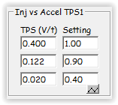
My current working table.

Accelerate Injector (mS)
I found the stock Amount values were to low in the higher RPM’s and the Decay values were way too high everywhere. I started changing these values once I was sure as to the effect this produced. In early testing, I used Amount values ranging from slightly greater than stock such as 10.5 mSec at 3000-5000 rpm to as much 80.0 mSec at 3000-5000 rpm with Decay values of as much as 3.0 to as little as 0.1. With a Decay value of 3.0, the added fuel cycle would be very short-lived, as little as 50-100 mSec at low Amount values, and at a Decay value of 0.1 it could last for 1000-1200 mSec or more with higher Amount values. For the lower RPM’s of 1000 and 2000, I would start with near default values of between 6-8 for the Amount and between 0.9-1.0 for the Decay. For 3000 RPM, I would start around 8.0 for the Amount and 0.6-0.7 for the Decay. For 4000 RPM, I would start around 8.5 for the Amount and 0.4-0.5 for the Decay. For 5000 RPM, I would start around 9.0 for the Amount and 0.4-0.5 for the Decay. When your engine air flow is better or your engine breathes easier from the air flow mods, the greater overall air flow efficiency consumes a relatively greater amount of air as compared to stock, particularly at the higher RPM’s, thus needing more fuel to go along with the greater quantity of air consumed. Also, the added fuel needs to last longer as the RPM’s increase too, thus the lower Decay values.
TIP: This is a balancing act with Amount and Decay. As you decrease the Decay value (less fuel going away with each rotor rotation), you must also slightly decrease the Amount at the same time in order to make the total overall additional volume of acceleration enrichment (AE) fuel rather constant. See Addendum B.

My current working table is below. I have tweaked it many times during the last several weeks. My acceleration is now tremendously improved with very few hiccups. I believe, from my testing, that most of you will need to develop your own tables’ specific to your car since even little changes in the table values will have significant effect on your AFR's. It will take many days of trial and error to fine tune these tables to work well with your car. A few important points: If you add too much to the Amount with a corresponding small Decay value, you will bog down during acceleration from too much fuel for too long and will not accelerate well. This will not hurt your car per say, but it defeats your purpose. If you start seeing AFR's in the 10's, back off. If your Amount is good, but you have a Decay value that is too large, the added fuel will end too quickly and you will go lean toward the end of the acceleration.

Accelerate Injector
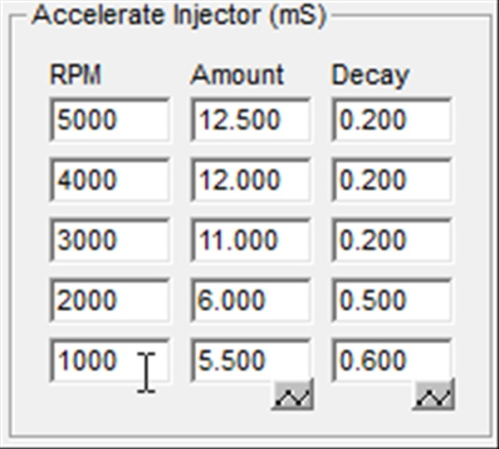
My current working table.

Now here are the results of my all of testing. Here is a WOT log from a run at 3000 rpm in third gear. The log speaks for itself. Note the lower knock during boost also.

[13B-REW v5.08]
Time(S) | AFR | EGT | PRM | PIM | PIM V | TPS V | InjFrPr | AirT | Knock | InjFrSc
23.906 | 13.469 | 1180.352 | 2990 | 7716 | 1.560 | 1.245 | 5.124 | 42 | 46 | 0.000
23.953 | 12.958 | 1181.818 | 3001 | 7716 | 1.560 | 1.245 | 5.116 | 42 | 44 | 0.000
23.984 | 12.867 | 1183.284 | 2997 | 7780 | 1.570 | 1.259 | 5.156 | 42 | 51 | 0.000
24.047 | 12.979 | 1181.818 | 3012 | 8036 | 1.610 | 1.362 | 5.228 | 42 | 23 | 0.848
24.093 | 13.101 | 1181.818 | 3015 | 10076 | 1.903 | 1.684 | 6.644 | 42 | 39 | 2.048
24.156 | 12.826 | 1183.284 | 3036 | 12156 | 2.228 | 2.309 | 6.612 | 42 | 34 | 3.176
24.187 | 12.448 | 1181.818 | 3031 | 12732 | 2.297 | 3.598 | 6.632 | 42 | 38 | 3.060
24.234 | 12.407 | 1183.284 | 3035 | 13196 | 2.360 | 4.233 | 6.616 | 42 | 41 | 2.940
24.281 | 12.295 | 1181.818 | 3056 | 13612 | 2.421 | 4.428 | 6.584 | 42 | 31 | 2.864
24.343 | 11.999 | 1181.818 | 3051 | 14084 | 2.487 | 4.433 | 6.584 | 42 | 38 | 2.780
24.390 | 12.601 | 1183.284 | 3075 | 14492 | 2.543 | 4.433 | 6.564 | 42 | 36 | 2.680
24.437 | 12.744 | 1184.751 | 3071 | 14892 | 2.604 | 4.438 | 6.540 | 42 | 34 | 2.532
24.468 | 12.918 | 1184.751 | 3094 | 15284 | 2.657 | 4.438 | 6.516 | 42 | 36 | 2.380
24.515 | 12.958 | 1186.217 | 3090 | 15652 | 2.709 | 4.443 | 6.508 | 42 | 38 | 2.332
24.578 | 12.836 | 1189.150 | 3114 | 15964 | 2.755 | 4.443 | 6.484 | 42 | 35 | 2.392
24.625 | 12.846 | 1189.150 | 3114 | 16252 | 2.797 | 4.443 | 6.456 | 42 | 24 | 2.460
24.672 | 12.683 | 1192.082 | 3135 | 16444 | 2.824 | 4.443 | 6.452 | 42 | 24 | 2.508
24.703 | 12.601 | 1190.616 | 3135 | 16532 | 2.837 | 4.443 | 6.420 | 42 | 27 | 2.544
24.765 | 12.356 | 1193.548 | 3152 | 16572 | 2.843 | 4.443 | 6.408 | 42 | 24 | 2.568
24.812 | 12.428 | 1193.548 | 3157 | 16612 | 2.849 | 4.443 | 6.376 | 42 | 28 | 2.572
24.859 | 12.244 | 1195.015 | 3171 | 16668 | 2.857 | 4.443 | 6.368 | 42 | 27 | 2.596
24.906 | 11.948 | 1196.481 | 3187 | 16700 | 2.862 | 4.443 | 6.336 | 42 | 30 | 2.620
24.953 | 11.826 | 1205.279 | 3201 | 16748 | 2.868 | 4.443 | 6.316 | 42 | 30 | 2.628
25.000 | 11.836 | 1206.745 | 3199 | 16772 | 2.873 | 4.443 | 6.312 | 42 | 35 | 2.644
25.062 | 11.856 | 1206.745 | 3229 | 16828 | 2.880 | 4.443 | 6.268 | 42 | 31 | 2.672
25.093 | 11.672 | 1211.144 | 3218 | 16860 | 2.887 | 4.443 | 6.272 | 42 | 36 | 2.680
25.140 | 11.550 | 1214.076 | 3245 | 16884 | 2.890 | 4.443 | 6.240 | 42 | 28 | 2.704
25.203 | 11.387 | 1212.610 | 3259 | 16916 | 2.893 | 4.443 | 6.220 | 42 | 33 | 2.720
25.234 | 11.397 | 1217.009 | 3262 | 16948 | 2.902 | 4.443 | 6.200 | 42 | 36 | 2.736
25.281 | 11.346 | 1215.543 | 3279 | 16988 | 2.904 | 4.443 | 6.184 | 42 | 28 | 2.768
25.343 | 11.234 | 1217.009 | 3280 | 17012 | 2.906 | 4.443 | 6.176 | 42 | 28 | 2.772
25.390 | 11.101 | 1218.475 | 3298 | 17028 | 2.910 | 4.443 | 6.140 | 42 | 31 | 2.788
25.437 | 11.326 | 1221.408 | 3314 | 17076 | 2.914 | 4.443 | 6.124 | 42 | 30 | 2.816
25.484 | 11.448 | 1225.806 | 3320 | 17092 | 2.920 | 4.443 | 6.104 | 41 | 35 | 2.832
25.531 | 11.091 | 1228.739 | 3330 | 17116 | 2.922 | 4.443 | 6.088 | 41 | 37 | 2.852
25.593 | 11.111 | 1228.739 | 3352 | 17124 | 2.923 | 4.443 | 6.064 | 41 | 36 | 2.876
25.625 | 11.040 | 1228.739 | 3352 | 17156 | 2.929 | 4.443 | 6.052 | 41 | 37 | 2.876
25.687 | 10.938 | 1233.138 | 3370 | 17180 | 2.932 | 4.443 | 6.020 | 41 | 36 | 2.908
AFR adjusted log for O2 sensor delay.

Get this right and accelerations put a smile on your face every time you stomp on the gas pedal. The car once again becomes its legendary self, the Rotary Rocket!!!

Recommended starting tables:

Most modified cars (mild air flow modifications). This is an estimation I believe should be close but will need refinement. Please report back to me so I can change these recommendations accordingly following testing by all of you make these changes.

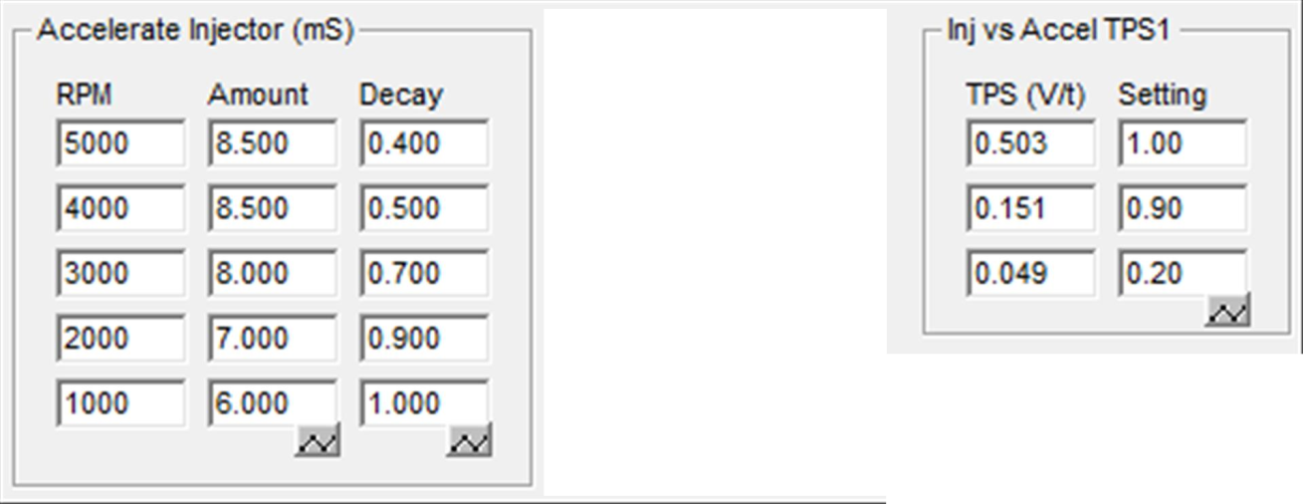

ADDENDUM A

TIP FOR LOGGERS: If you are able to log using the Datalogit FC-edit software, there is a shortcut that will make choosing the more ideal third row TPS (V/t) value easier for the Inj vs TPS1 table. Do some acceleration logging with advanced and Aux (need your AFR readings) before making any of the changes in the acceleration enrichment (AE) tables and log varying pedal movements of very mild, mild, and mildly moderate accelerations at around 3000 rpm in third gear. Analyze the logs and look at TPS voltage vs. AFR. One important point to remember is that the AFR reading in the log is actually delayed since your O2 sensor is somewhere in your downpipe, stock right after the turbos, mine in the mid portion of the downpipe. This means that you have to use the AFR reading about 150-300 mSec after the TPS voltage reading in the log (typically around 4-5 rows down) to accurately correlate between the two readings. The exhaust takes that much time to reach the O2 sensor to be measured. Once correlated, look and see at what change in TPS voltage/time the car starts to go lean (at least 0.5 AFR) with acceleration. For the third row for me, that was around a .020-.025 in voltage change. This is my sweet spot. You can do the exact same thing for your second row value, but this second row TPS value has to be done later at the very end of everything else since this value is highly dependent on the correct third row setting (cannot be lean with mild pedal movement before even reaching the moderate pedal movement) and the correct settings in the Accelerate Injector table (which affect the second and first row settings more significantly).

ADDENDUM B

Let's look at the volume of additional fuel during the acceleration enrichment (AE) using the stock default Accelerate Injector table. This is the total amount of additional injector on time in milliseconds for the whole acceleration enrichment (AE) cycle provided by this table at each rpm level. This is calculated by simply adding together all the fuel from each and every rotor rotation until all the extra fuel is gone and assuming using 100% of the fuel at WOT on the first row of the Inj vs. TPS1 table.

5000 rpm 7.5mSec-1.0mSec=34.4 mSec total
4000 rpm 7.5mSec-1.0mSec=34.4 mSec total
3000 rpm 7.5mSec-1.5mSec=24.3 mSec total
2000 rpm 8.0mSec-1.8mSec=24.0 mSec total
1000 rpm 6.0mSec-2.0mSec=13.2 mSec total

The Amount and Decay values have to be changed with the total overall volume in mind. This is a balancing act to try to keep the overall total volume near the same but make it last long enough (not to go lean near the end of the enrichment cycle) and once you zero in on the total additional enrichment fuel needed for your car at each rpm level.

Now contrast these stock default total volumes for each rpm to my current working table for Accelerate Injector.

5000 rpm 12.5mSec-0.2mSec=397 mSec total
4000 rpm 12.0mSec-0.2mSec=366 mSec total
3000 rpm 11.0mSec-0.2mSec=308 mSec total
2000 rpm 6.0mSec-0.5mSec=40 mSec total
1000 rpm 6.0mSec-0.6mSec=33 mSec total

Now you can see why my accelerations were so poor with AFR's of 20, particularly at 3000 rpm and above, using the stock default acceleration enrichment (AE) tables and how grossly inadequate the stock default tables are for my car. I added over 10X more total enrichment fuel in the 3000-5000 rpm range to achieve excellent accelerations.

THE END

