Older cars used pills to help control seq. turbo transition, newer cars had permanent holes drilled into turbo #1 vacuum pipe.
Wastegate (shorter hose TOP) - 0.064in (Drill # 52)
Precontrol (longer hose BOTTOM) - 0.059in (Drill # 53)

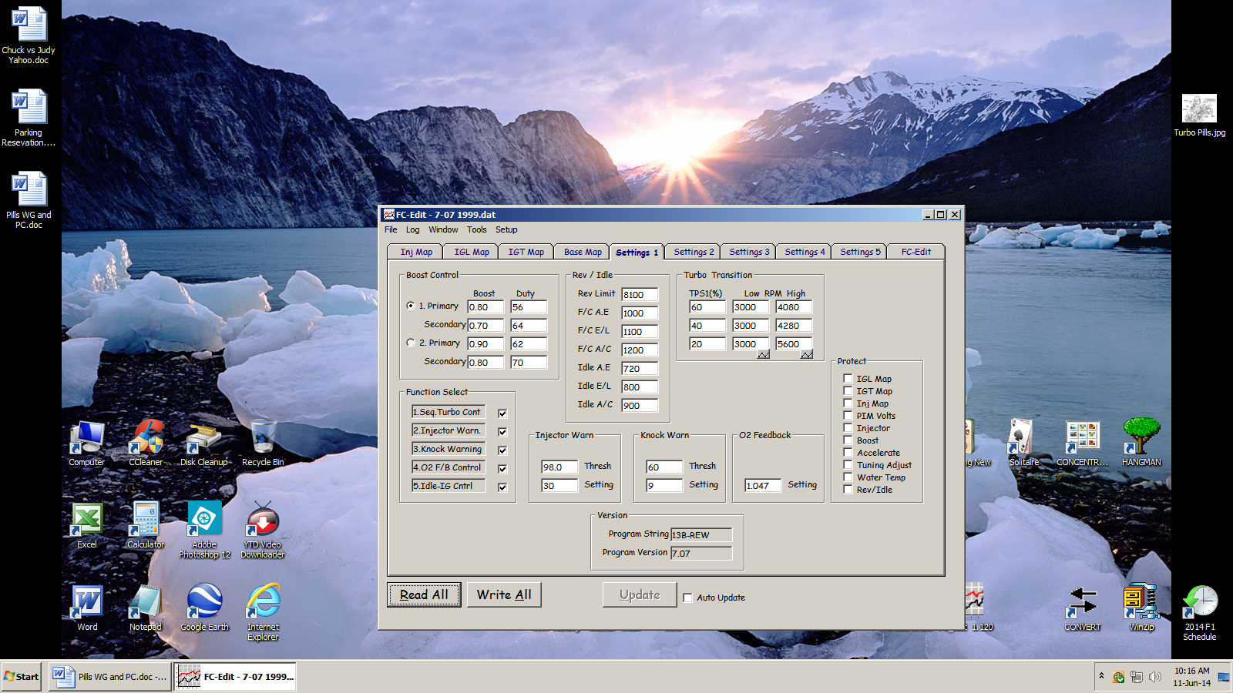
stock map

The "high" value is for acceleration" and the "low" value is the hysteresis value, the rpm when you are decelerating. Change all three "low" values from 3000 to 3500. arghx

From ARGHX



