FD RX7 Auto to Manual Conversion
  - Wiring

Brief Instructions
Section 1 includes just a list of what to cut and what to connect. Details and pictures are listed in further sections.

AT Engine Wiring Harness Modifications
Speed Sensor
The Auto Transmission Engine Wiring harness already has a connector that plugs directly into the manual transmission speed sensor. The wire is the proper length to reach to the back of the Manual transmission, so no modification is necessary.

Starter inhibitor bypass
- To allow the starter to work, you must bypass the inhibitor switch which was in the automatic transmission by locating the gray 9 pin connector that connected to the auto transmission. Cut the lower gauge (thicker) Blue/Yellow and Red/Yellow (2 outside pins lower row) wires from the connector (wiring harness side) and crimp together with a 14-16 gauge butt crimp.

Reverse Switch (Sensor)
- Purchase at least one of this 2 pin connector that connects to the reverse switch (Suggest 1 spare in case of damage when inserting the pins): https://www.corsa-technic.com/item.php?item_id=553
20-24 AWG and 1.4-2.4mm (for this and all the connectors listed here)
- Locate the AT Inhibitor switch (Gray 9 pin) and cut the Brown/Black wire and the Yellow/Blue wire. Extend these wires to the same length as the 8 pin yellow connector that went to the back of the auto transmission (nearly same length as the speed sensor connector). Connect these two wires to a crimp pin and plug into the purchased reverse connector listed above.
Ideally wrap the wires in the similar style wire harness wrap cover sleeve which can be purchased on line (Amazon).

1st-2nd Switch and Neutral Switch
The 1st- 2nd switch uses a 4 pin connector with 2 blue wires for 1st gear and 2 green wires for 2nd gear.
One blue wire connects to CPU pin 2K for 1st, and the other blue wire connects to ground.
One green wire connects to CPU pin 2L for 2nd, and the other green wire connects to ground.
The neutral switch uses a 2 pin connector with one pin to ECU pin 1R and the other side to ground.
The 1st gear, 2nd gear, and netural switches all work in a similar fashion. When in 1st, the 1st gear switch connects the two wires together, and is open in any other gear (same for 2nd and neutral).
- Purchase at least one of this 4 pin connector to connect to the 1st-2nd switch (spare suggested): https://www.corsa-technic.com/item.php?item_id=554
- Purchase at least one of this 2 pin connector to connect to the neutral switch (spare suggested): https://www.corsa-technic.com/item.php?item_id=700
- Locate the 8 pin yellow connector that connected to the back of the auto transmission. Remove the following 4 pins: White, Yellow, Green, Red (to be used for the neutral switch). Don’t cut them as these pins fit perfectly in the connectors listed in these instructions.
Yellow already connects to the 2nd gear input on the ECU, so no additional wiring inside the car is required.
Green already connects to the 1st gear input on the ECU, so no additional wiring inside the car is required.
White was ground, but needs to be connected to ground inside the car once the EC-AT (Auto ECU) is removed. The EC-AT provided the ground.
Red will be used for Neutral which is connected to EC-AT pin 2R (Red).
CPU Neutral input pin 1R (Yellow) connects to EC-AT pin 1C (Yellow).
- Inside the car, to connect our red neutral switch wire to the ECU, we
remove pin 2R from the Auto ECU and insert into the ECU pin 1R
Red Auto ECU pin 2R – (was ATF Thermosensor input) repin to ECU pin 1R

These wires have a dashed line on them that isn’t part of the color code.
Search Youtube for a video titled “Removing a terminal from a connector” or similar video. I bought a pin removal tool from Amazon, but it was so flimsy that a tiny eyeglasses repair screwdriver worked far better for me. The guy on the video had a similar experience.
- Cut the remaining 4 unused wires (Yellow/Red, Green/White, Blue, Brown) from the 8 pin yellow connector.
- Test fit the 4 pin connector into the 1st/2nd switch on the manual transmission. Note which side has 2 green wires, and which side has two blue wires. Connect the green pin just removed from the AT wiring harness 8 pin connector to match up with one of the blue wires on the 1st-2nd sensor.
This is because the green pin on the AT ECU wiring harness side already connects to ECU 1st gear input, but the first gear sensor uses the blue wires.
- Connect the yellow pin removed from the 8-pin connector to match up with one of the green wires on the 4 pin 1st-2nd sensor.
- Connect the red pin removed from the 8-pin connector to one side of the neutral switch connector.
- For the 3 ground pins, you need to connect the white wire from the wiring harness to 3 separate white pins for the 1st, 2nd, and neutral connectors. I made this 4-way connection using a 2 way butt connector, but there are lots of ways to do this.
I cut the original white pin back about 2 inches and made two more two 2-inch “pigtails” with a white wire crimped to a pin from the purchased connectors.
Then I twisted the original wiring harness white wire to one of the pigtails I made and crimped into one side of the butt connector. I twisted the original white pigtail that I cut off with the other pigtail I made. I did it this way so there would be matching thickness on each side no matter what gauge wire you used for the pigtails.
You should now have the following 4 connectors all roughly the same length:
Speed sensor
Reverse switch
Neutral switch
1st-2nd Switch

Interior Connections
NEUTRAL SWITCH CONNECTION
Red pin 2R connects to the Neutral switch wire that we hijacked from the ATF sensor.
Yellow pin 1R on the CPU (neutral input) connects to EC-AT pin 1C (yellow) which we need to connect to the red wire above.
- Inside the car by the ECU: Cut red pin 2R on the 20 pin EC-AT connector from the EM harness (2nd pin from the end)
- Cut Yellow pin 1C from the 16 pin connector on the Front wiring harness and then connect the two wires together using a connector so someone could actually pull the engine without cutting this wire.
GROUND for NEUTRAL/1ST/2nd
- Verify if wire 2L on the ECU-AT (5th from the end) is already connected to ground. If so, then no action is required. If not, then cut white wire pin 2L on the ECU-AT (5th from one end) and connect to a ground lug.
CLUTCH SWITCH CONNECTION
- Cut Green/White pin 2P on the ECU-AT (3rd pin from the end on the 20 pin black connector) and connect to one side of the clutch sensor. This works because pin 2P is connected to ECU pin 1Q black/orange (shifting / clutch pedal pressed).
- Run the other pin to ground.

Connector Detail
For all of the connectors, order as 20-24 AWG and 1.4-2.4mm.

Reverse Switch connector on the wiring harness side:
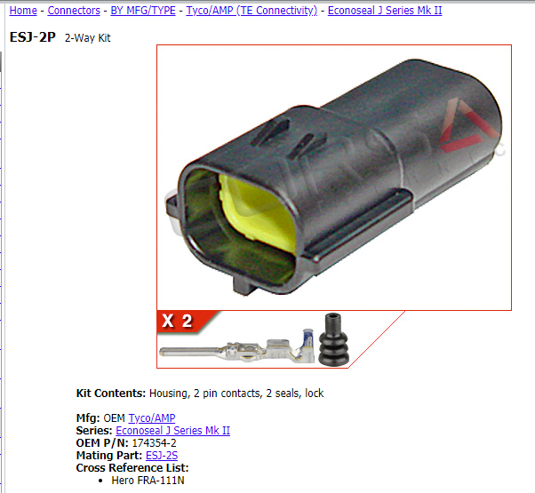

Neutral Switch connector on the wiring harness side
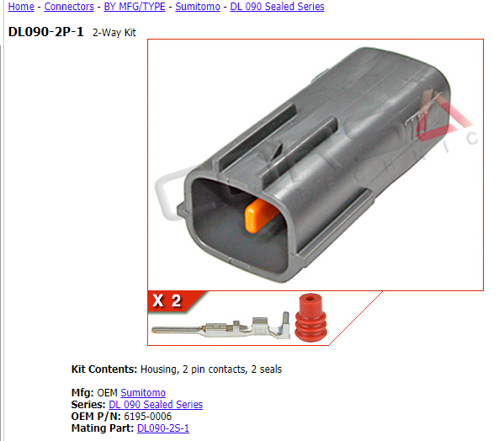

1st-2nd gear connector on the wiring harness side
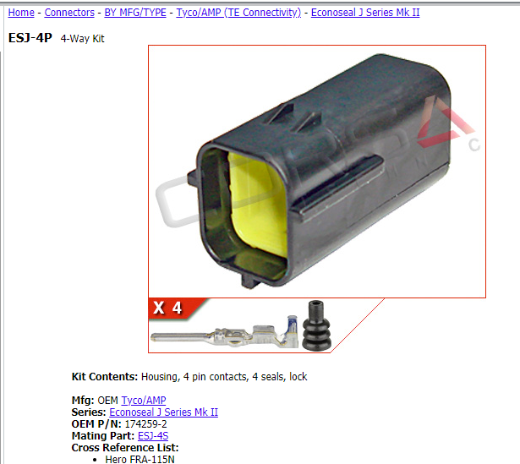

Detailed Auto to Manual Rewire Instructions

AT Inhibitor Switch Bypass
Section A-2, Page Z-34
Gray connector with 9 pins.
- Bypass the inhibitor switch in the automatic transmission by connecting Blue/Yellow to Red/Yellow (2 outside pins lower row).

Reverse Switch (Gray or white 2 pin)
AT Inhibitor switch also had 2 wires for a reverse switch, so these are directly used. Just extend the wire to be as long as the 8 pin solenoid valve and speed sensor connectors that reach to the back of the AT / MT.
- Connect AT Inhibitor switch (Gray 9 pin) Brown/Black wire to one side of the reverse switch.
- Connect AT Inhibitor switch (Gray 9 pin) +12V Yellow/Blue wire to the other side of the reverse switch.
OK, I got the reverse lights to work! Just take the brown/black wire out of the grey connector, connect it to one of the reverse wires from the manny, and connect the other wire to a ground. I'm not sure on the color for the JDM though.
- oops, I messed up. I meant to say the other wire goes to a constant 12v power. sorry about that!
https://www.rx7club.com/3rd-gen-archives-73/mt-swap-161482/page3/
By Zyon13B

Neutral / 1st / 2nd Gear Sensors
The neutral, 1st gear, and 2nd gear (N/1/2) sensors are all 2 wires each with 1 side to ground and the other side to the CPU. The AT wiring harness has a yellow 8 pin connector near the near the speed sensor connector that is already the proper length to connect to the Neutral and 1st-2nd sensor.
- Locate the 8 pin yellow connector and remove the following 4 pins: White, Yellow, Green, Red.
Note: These wires have a dashed line on them that isn’t part of the color code.
- Cut the remaining 4 unused wires (Yellow/Red, Green/White, Blue, Brown)
N/1/2 sensors. We will remove 4 pins from this connector and then cut cut this connector off and use 4 out of the 8 wires.
Two of the wires already connect to the 1 and 2 input on the ECU: Yellow (2nd) and Green (1st).
One ground wire (W) is already available, so we will utilize it for the 3 ground wires required. I used a butt connection crimp with 2 wires in each end.
Use the Red wire for neutral which leaves 4 solenoid wires unused.
Clutch sensor – 1 side to ground, other wire to ECU pin 1Q
Reverse switch – Locate AT Inhibitor switch (Gray 9 pin) Brown/Black and Yellow/Blue wires and extend as far as the above 8 pin connector and add the OEM mate connector for the reverse sensor.
Starter AT Inhibitor bypass – Connect AT Inhibitor switch (Gray 9 pin) Blue/Yellow to Red/Yellow (these are the 2 thicker gauge wires).

Y – EC-AT 1B - [note 48] on CPU – 2L – 2nd position to ECU already to Green wire on 4 pin sensor connector
G –EC-AT 1D - [note 47] on CPU – 2K – 1st position to ECU already to Blue wire on 4 pin sensor connector
R – EC-AT 2R – (ATF Thermosensor input) – Use this for Neutral, wire EC-AT pin 2R to ECU pin 1R
W – EC-AT 2L- Ground

Y/R – EC-AT 1F (Output Solenoid Valve line pressure) – Not used
G/W – EC-AT 2F – (Output Solenoid Valve lockup control) – Not used
L – EC-AT 1M – (Output Solenoid Valve Lockup) – Not used
BR – EC-AT pin 1O – (Output Solenoid Valve overrunning clutch) – Not used

Neutral Switch (ECU 1R / Ground)
Neutral switch has an orange 2 pin connector and is located at the top left side of the transmission.
- Inhibitor switch LG/W wire (N selection as seen on page Z-70) to one side of the neutral switch
- Other side of neutral switch sensor to ground and this ground also feeds one side of the 1st and 2nd gear sensors too.
- At the X-14 connector, pick up the LG/W neutral wire which fed the cluster PRNDL display and connect to pin 1R on the ECU.

Notes:
The neutral wire from inhibitor switch was just driving N on PRNDL display of the cluster (didn’t connect to AT-ECU). If the AT-ECU were left in place, we’d need to cut the other side of the 1R wire so the AT-ECU output doesn’t conflict with the neutral switch.
AT neutral switch starts at AT Inhibitor switch LG/W and goes Instrument Cluster via X-14 connector which ties Emission (EM) to Dash (D).
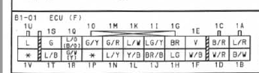
Above from page Z-28
I bypassed the starter interlock....and the neutral switch is not connected (my AWS is removed) Manual functions work just fine. AWS increases cold start to 3k RPM.
AT uses Inhibitor OK (Neutral or Park) signal input to EM-AT (ECU AT). Then EM-AT (ECU AT) drives output pin 1C to ECU pin 1R (neutral switch input for a MT).
- MT: Z-34 page shows Neutral switch connected to ECU input pin 1R
- AT: Z-34 page shows Neutral input ECU pin 1R connected to EC-AT control unit which on page Z-70 shows connected to EC-AT output 1C
Connector B1-50 shown on Page Z-35
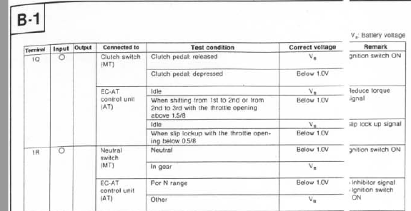
X-14 Connector wire codes on Z-117 for MT and AT
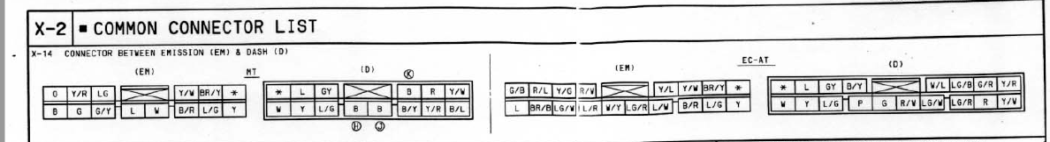

1-2 Switch (1st to ECU 2K, 2nd to ECU 2L)
Sensor with 4 pins and 2 green and 2 blue wires.
1st gear switch connections are the two blue wires.
2nd gear switch connections are the two green wires.
- 1st gear sensor wire to Inhibitor switch BR/W (L selection as seen on page Z-70).
- Other side of 1st gear sensor to ground.
- Connect AT-ECU pin 2Q BR/W (L selection) to ECU 2K Y/W (1st gear)

- 2nd gear sensor wire to Inhibitor switch L/R (S selection as seen on page Z-70).
- Other side of 2nd gear sensor to ground.
- Connect AT-ECU pin 2S L/R (S selection) to ECU 2L W/G (2nd gear)

Or, grab the L and S wires at the X-14 connector where they drove the PRNDL display. See page Z-48 for dash side color codes of X-14 or from the AT-CU pin 2Q brown/white (L selection) and pin 2S Blue/Red (S selection)
From what I recall... it relates to emissions however to what extent I do not know -- You know how you can start the car in gear and the AWS wont hop up to 3k? That is part of the 1-2 switch functions.
Note: Normally starting car cold will idle to 3k RPM, but doesn’t do that if it detects car is in gear.
Connector shown as B1-51 on Page Z-35
1st gear to 2K on ECU
2nd Gear to 2L on ECU

Clutch Pedal switch (B1-52), Page Z-35
On the AT cars, the EC-AT signals the ECU that the car is changing gears. On the MT cars, the clutch pedal switch signals the ECU that the car is changing gears.
- Cut Green/White pin 2P on the ECU-AT (3rd pin from the end on the 20 pin black connector) and connect to one side of the clutch sensor. This works because pin 2P already wired to ECU pin 1Q black/orange (shifting / clutch pedal pressed).
- Run the other pin to ground.
From FSM page Z-30, 1Q is L/O or B/O, so Blue/orange or Black/Orange

Cruise Control
Note: Haven’t tested this since the cruise on my car didn’t work in the first, but the wiring diagrams support this.
- Cruise Control ECU pin G (Auto Blue/White, Manual Blue/Orange) must wire to clutch switch signal side at AT pin 2P or ECU 1Q.
- Clutch Switch wire L/O to cruise control unit section Q (pg Z-104 in FSM) and wire to the same wire used for
the clutch switch. (0V will cancel cruise control)

Page Z-34: Engine clutch switch connection to cruise control.
Page Z-104: Cruise Control pin G (Blue/Orange or Blue/White) to clutch input on ECU (above step ECU-AT pin 2P or ECU 1Q.

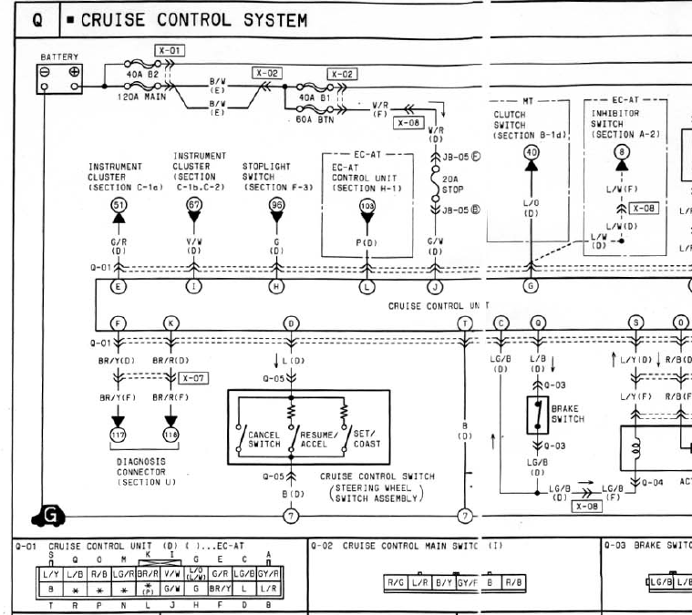

Clutch Switch to ECU

Connector into clutch switch MTU.IL-2S-2
https://www.corsa-technic.com/item.php?item_id=966&page=3&category_id=125
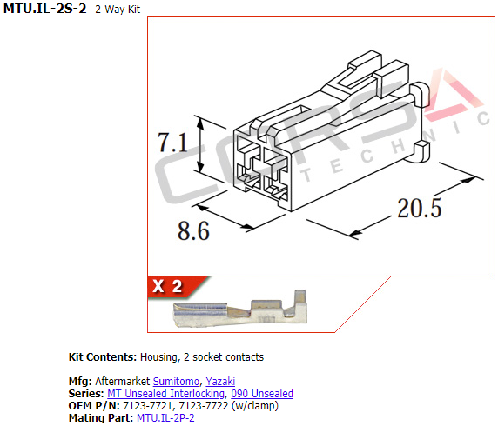

Clutch Safety Switch
- You should be able to route the starter relay in the footwell wires to the clutch safety switch so the clutch must be pushed in for the starter to work. I haven’t done this yet, but will some day. Also, the Miata part number FB01664D0 will fit with some modification. The wires come out the wrong side and interfere, so you have to clip the plastic post the wires are tie strapped to and fold them down and glue them with epoxy. I did a test fit and it does fit on the pedal fine after the modification.

FSM Wiring Diagrams Breadcrumbs

EC-AT (Auto ECU) – Page Z-70

Starter Interlock Switch (Clutch Safety Switch) Section A-1

OEM Connectors

Clutch Safety Switch
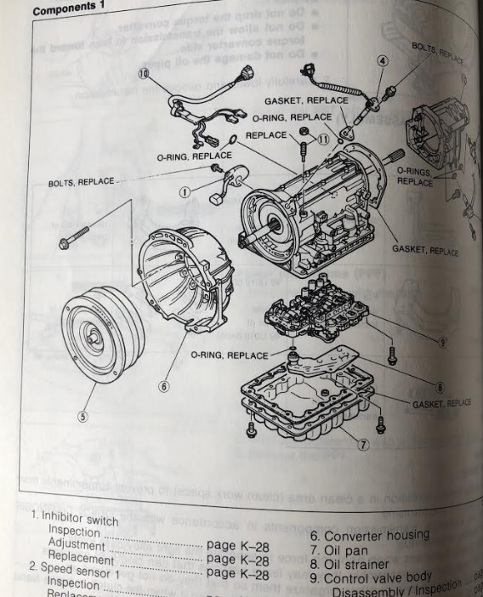
Note from forum: To enable the starter, you must bypass the starter inhibitor switch located in the automatic transmission. Connect pins 8&9 to each other on the ECU wiring harness (car side).
- Ideally connect the starter inhibitor switch to the clutch pedal switch. NLA, but Miata style part# FB01664D0 is still available and seems physically identical (Bought 2 used and compared and they seem the same). ECU expects a short to enable starter.
Wire Size:
18 guage
2.1 mm insulation

Switch Connector
https://www.corsa-technic.com/item.php?item_id=344&category_id=126

Wiring Harness connector 250.ARM-3S
https://www.corsa-technic.com/item.php?item_id=345&category_id=126

Manual Transmission Overview
The manual transmission has the following sensors / switches:
- Speed sensor
- Reverse light switch
- Neutral switch
- First & second gear switch

Speed sensor
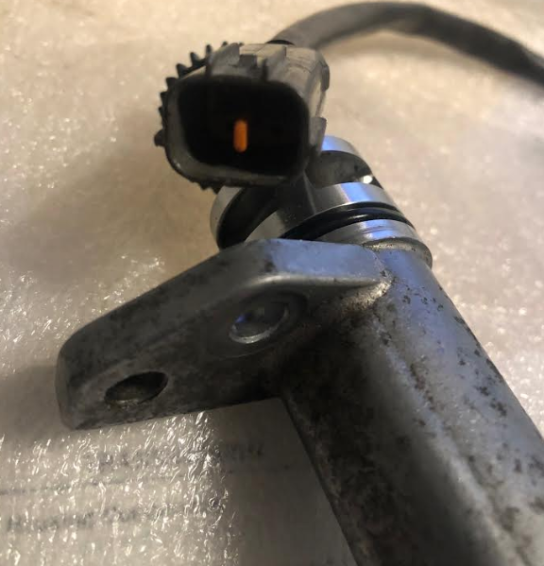
The speed sensor drives the speedometer, and it appears to be able to connect to the automatic ECU wiring harness same orange connector.
- Connect the manual transmission speed sensor orange 2 pin connector to the matching orange connector of the ECU wiring harness. The wiring will be too long and will need to be tucked out of the way since the manual speed sensor has a long pigtail and the automatic speed sensor located in a similar location has an integrated stub connector.

Replacement Sensor Part #
$168.64 from RealMazdaParts.com R505-17-400B
$2560 Standard Motor Vehicle Speed Sensors SC280 for around $260 from Summit Racing

Connector Neutral switch reversed gender

Reverse (Back-up light switch) (Yellow or white)
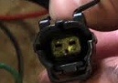
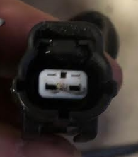
See FSM page J-15, number12. The reverse switch is located on the left hand side of the car (US driver side) on the rear of the transmission. It is a 2 pin connector that is whitish, greyish, or yellow.
Shorts in reverse, open in neutral or 1st.
Forum notes: If you use the auto harness, you have to connect pins 2 & 7 on the auto inhibitor switch harness to the reverse switch. (I have no idea how he calls these 2 pins 2 and 7)Based on pg Z-70, I got reverse lights working by connecting inhibitor switch Y/L (switched 12V) to BR/B (Yellow with blue line to Brown with black line)

Operation
Shorts when in reverse, open otherwise

Replacement Sensor Part #
R508-17-640 from Mazda around $35
Standard Motor Neutral and Backup Safety Switches LZS319 $54.19 from Summit Racing

Connector Detail ESJ-2S
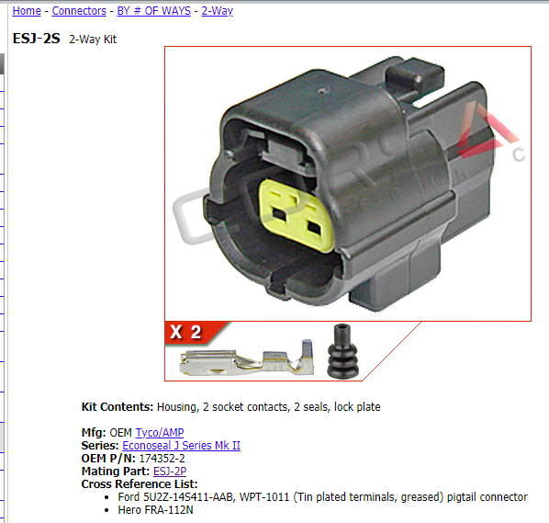
https://www.corsa-technic.com/item.php?item_id=549&category_id=125

Mating Connector Detail
https://www.corsa-technic.com/item.php?item_id=553

Neutral Switch (Orange)
Orange 2 pin connection
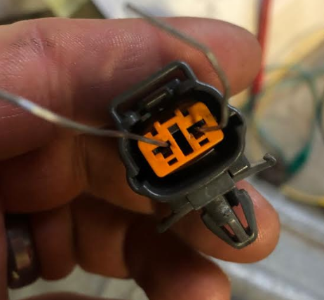
See FSM page J-29, number 4.

Operation (Retest to verify it shorts in neutral or not)

Replacement Sensor Part #
Standard Motor Neutral and Backup Safety Switches LZS319 $54.19 from Summit Racing

Sensor Connector DL090-2S-1
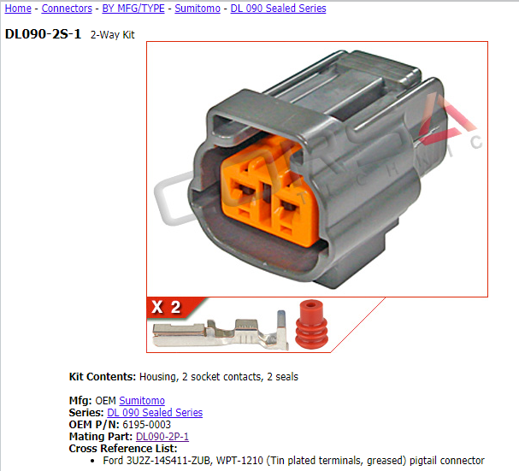
https://www.corsa-technic.com/item.php?item_id=654&category_id=147

Mating Connector Detail
https://www.corsa-technic.com/item.php?item_id=700

1-2 Switch (First/second gear sensor), 4 pin Neon Yellow
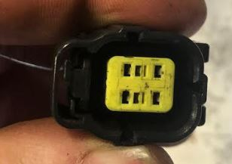
This sensor has 4 wires on it, 2 blue (1st gear)and 2 green (2nd gear)
See FSM page J-29, number 5.
Located on passenger side (US) rear of transmission.

1st gear switch connections are the two blue wires.
2nd gear switch connections are the two green wires.
Note that what appears as a middle row is the keying and is not connected to anything.
Auto trans speed sensor 1 (unique speed sensor for TCU) uses same connector but only has 2 wirs out of 4.

Sensor Connector ESJ-4S
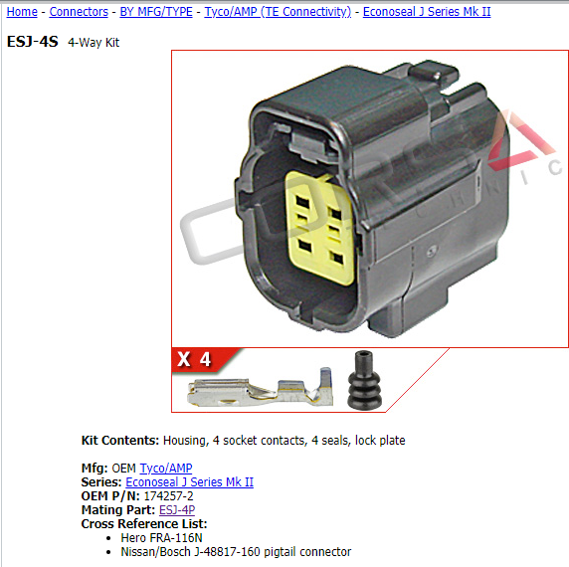
https://www.corsa-technic.com/item.php?item_id=551&category_id=109

Mating Connector ESJ-4P
https://www.corsa-technic.com/item.php?item_id=554

Auto Transmission Sensors
Speed sensor 1 – page K-43 #14, this is unique to the automatic transmission, and likely used by the automatic TCU.
Speed sensor 2 – page K-43 #17, this is similar to the speed sensor on the manual transmission and may use a matching connector. Note that auto speed sensor has an integrated connector, but the manual speed sensor has a pig tail connector.
Pulse sensor – page K-43, # 15. This is unique to the automatic transmission, but it has the same style neon yellow 6 pin connector that is utilized by the manual first/second gear sensor. We should be able to use the connection from the automatic’s engine wiring harness to connect to this.

