MRT Mazda Rotary Transmission Repair-Tom Shirk
Shift Centering Spring Replacement
- Put trans in neutral. Remove cover plate, 19mm indent bolt, ball and spring cover.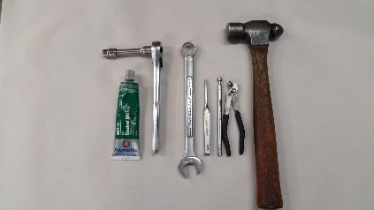 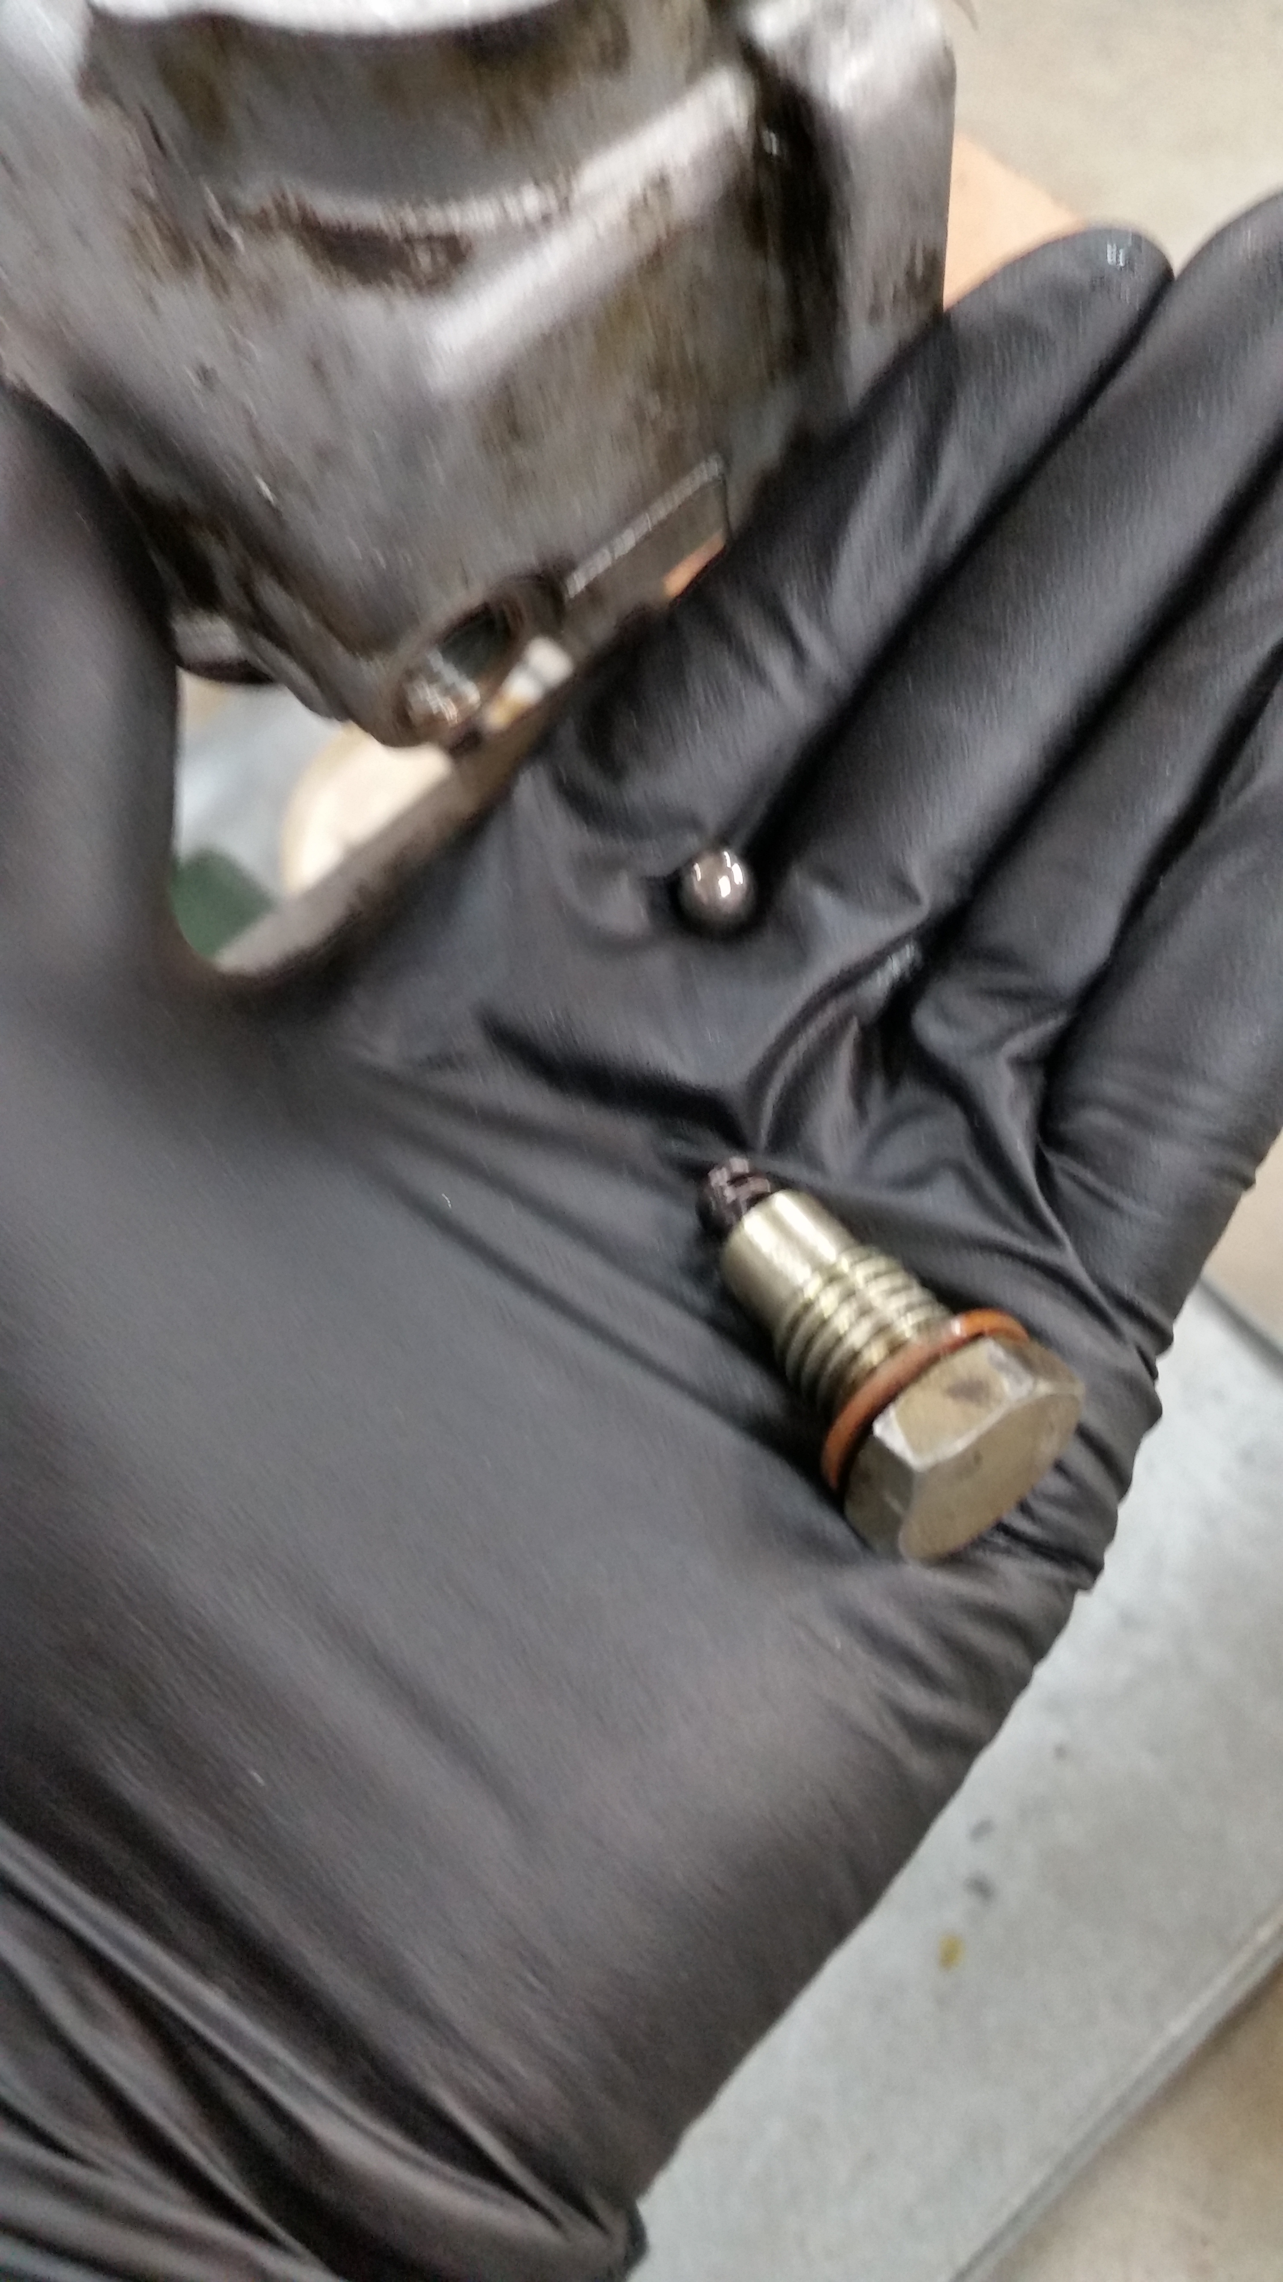 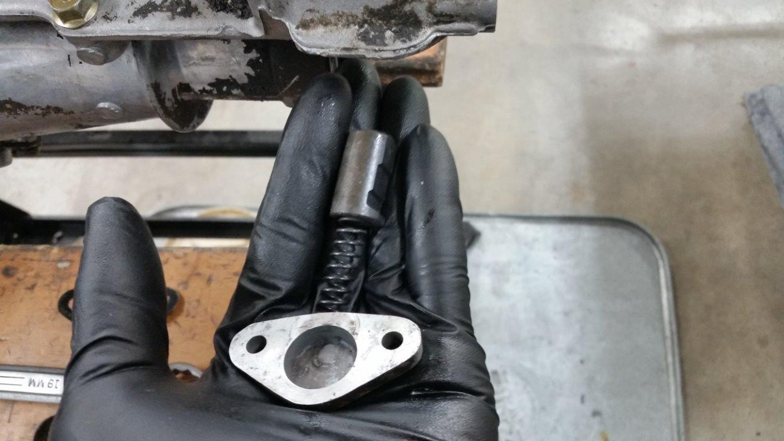
- Use 3/16” pin punch to drive out shift block pin. YOU MUST drive out the pin in UPWARD direction or pin WILL JAM against inside of the housing.
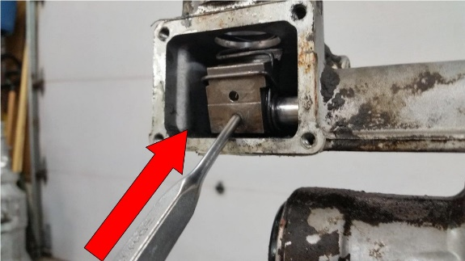
- Use mini slip-joint pliers to roll shift rod up until it stops and work rod forward.
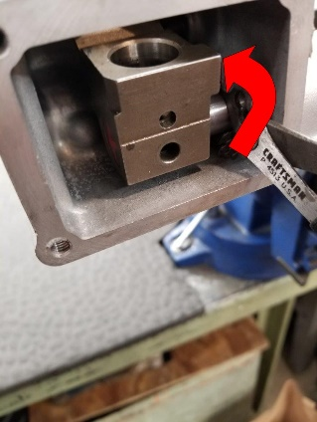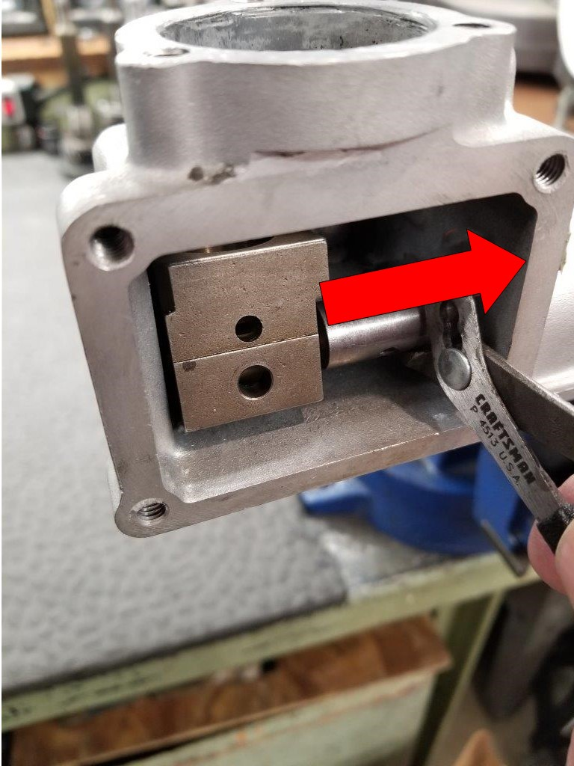
- Position centering spring and start new roll pin (M5x26). Reinstall block in reverse order. Line up roll pin on rod pin bore and drive in pin. Next install plunger and spring cover (8-11 Nm). Hold shift block in neutral position when installing indent ball and 19mm bolt (4-6 Nm).
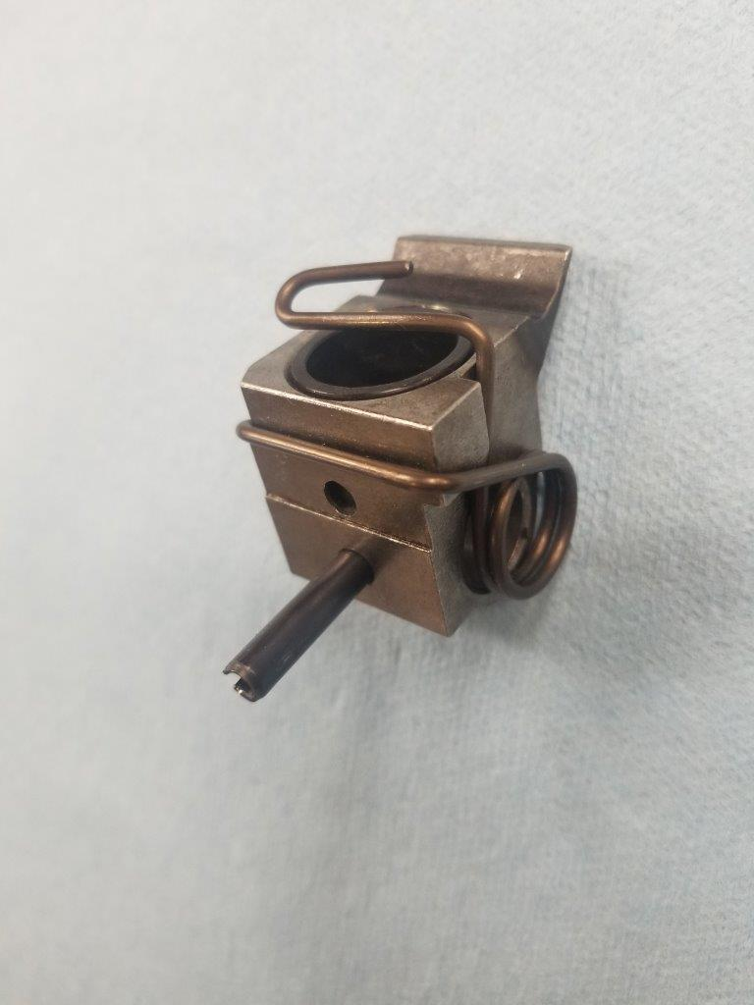
- Apply Permatex Gear Oil Sealant to cover plate (8-11 Nm). Fill Shift tower to top of shift block with synthetic gear oil. Apply sealant to shift boot plate (8-11 NM).

