S5 Rx7 Electronic Cruise Control Repair

This write-up covers the inspection and repair of an electronic cruise control unit for the S5 FC. Various troubleshooting techniques are available in the factory service manual. This write-up is in addition to those techniques.

Problem: Cruise control unit would not engage and take over throttle control.
FSM Pages T69-77
Diagnostics performed:
Unit diagnostic was enabled and the steps outlined in FSM to inspect all devices were followed. All devices tested good. Cruise control unit indicated a system short. Author went on to test individual pins at the cruise control unit. Unit pinout can be found on page T-76. Pin b (motor output) was found to put out 0.07v instead of the approximate 12v required to actuate the cruise control motor. Cruise control unit was removed from the vehicle and is shown in Figure 1.

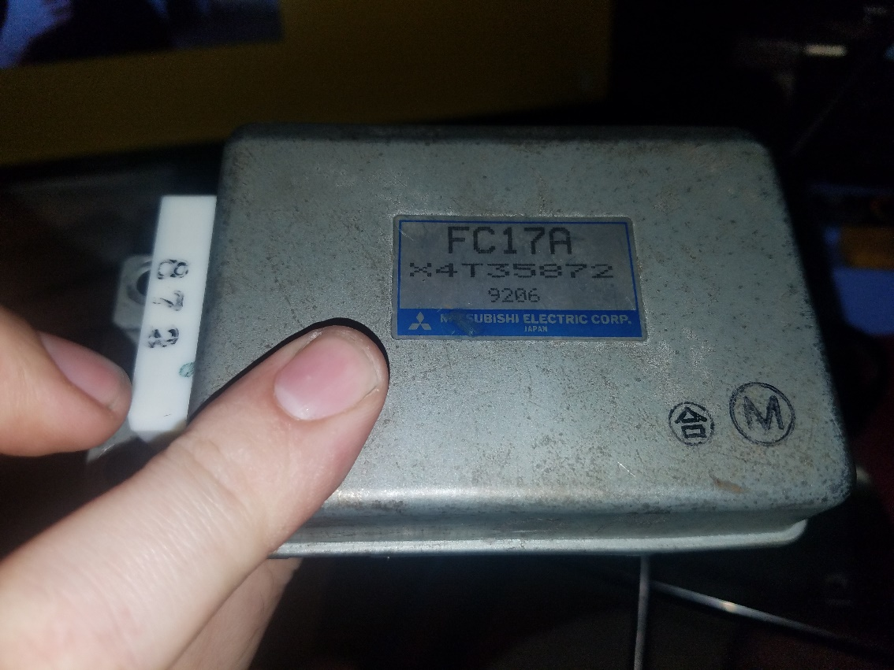
Figure 1 Cruise Control Computer Unit

An electrical short meant that some voltage was escaping to ground, so a multimeter was used to check the connectivity between the faulty pin b and the ground pin t as shown in Figure 2.

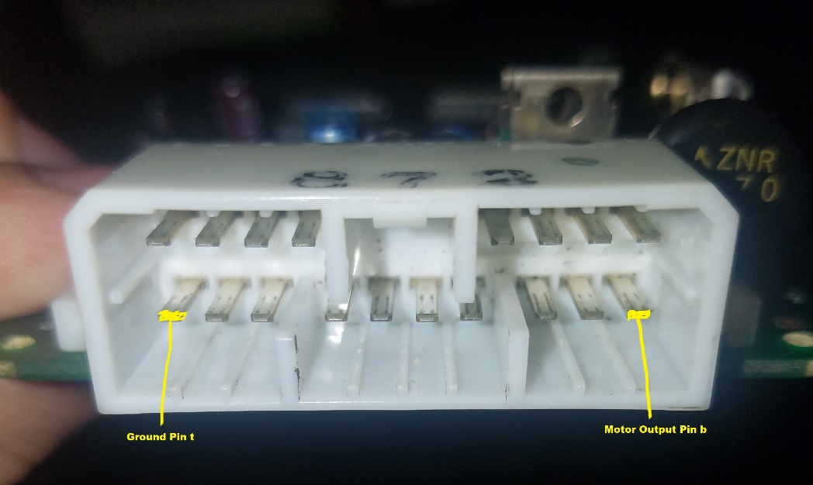
Figure 2 Faulty Motor Output Pin

Upon discovery of faulty pin, circuit board was removed from housing. Housing is held on by metal tabs that can be expanded and pried off as shown in Figure 3.

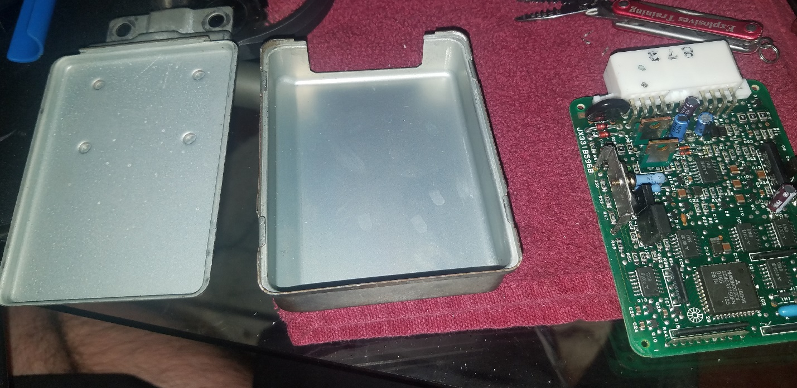
Figure 3 Opened Cruise Control Unit

At this point, the circuit board was traced with a multimeter, starting with the faulty pin, to find the location of the short. The path of lowest resistance was followed until a component was identified as a low resistance bridge between the output pin and the universal ground of the circuit board. An IC chip was identified as the source of the short circuit and is shown in Figure 4 with the shorted pins highlighted. The IC chip is a Toshiba TA8050P. To ensure that the circuit was indeed shorted out and not open by design, the chip specifications were searched. The specifications can be found at http://www.datasheetcatalog.com/datasheets_pdf/T/A/8/0/TA8050P.shtml. These specifications describe the circuit as a 1.5-amp motor driver with brake function. The faulty output was related to a motor function, so this indicated that the chip was the likely culprit. Further reading not only specified that the shorted pin on the chip should not be shorted to ground, but also that if a short in the motor driver circuit occurs, the chip can utilize another pin to indicate the short. This works as a safety to ensure that the cruise control circuit disengages in the event of failure rather than malfunction with unintended consequences. Replacement chips can currently be found on Ebay for approximately $1.50 apiece.

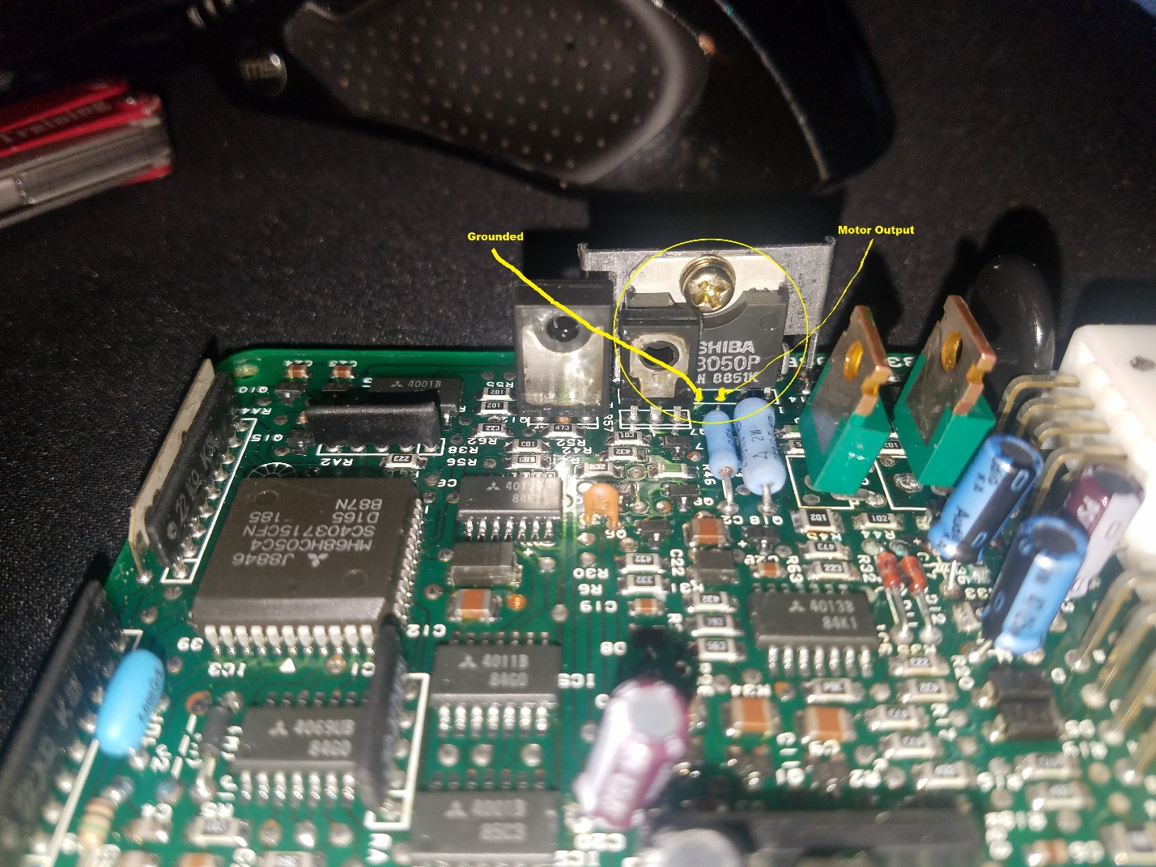
Figure 4 Shorted IC Chip

Replacement of this chip was tedious. There was minimal room to work with a soldering iron, and the circuit board is printed on both sides, so successful connections needed to be reestablished on both sets of contacts. The de-soldering process was slow and tricky. To aid in successful de-soldering, a high-lead content solder was used and added to the existing soldered joint. Once the new solder melded with the existing solder joint, excess solder was removed with a solder sucker. Once the majority of the old solder was removed, new solder was to the joint. This solder was heated through with the iron to allow the pins to easily slide through for removal. The first item to remove from the circuit board was the metal heatsink that the motor driver chip was attached to. The screw was, and the heatsink was de-soldered from the circuit board. Next, the IC chip was removed. This is a tedious process if you attempt to remove the chip intact. The other option is to bend the chip and break off the pins. However, you risk damage to the board if you do this. Individual pins are quicker to remove than the whole IC.
Before reinstalling the motor driver chip, the circuit board and replacement components were prepared. Solder had flowed into the holes of the circuit board and closed off so that pins could not be inserted, as seen in Figures 5 and 6. To reestablish the holes in the circuit board, a small watch drill was used to broach out the excess solder from the holes. This drill is shown in Figure 7.

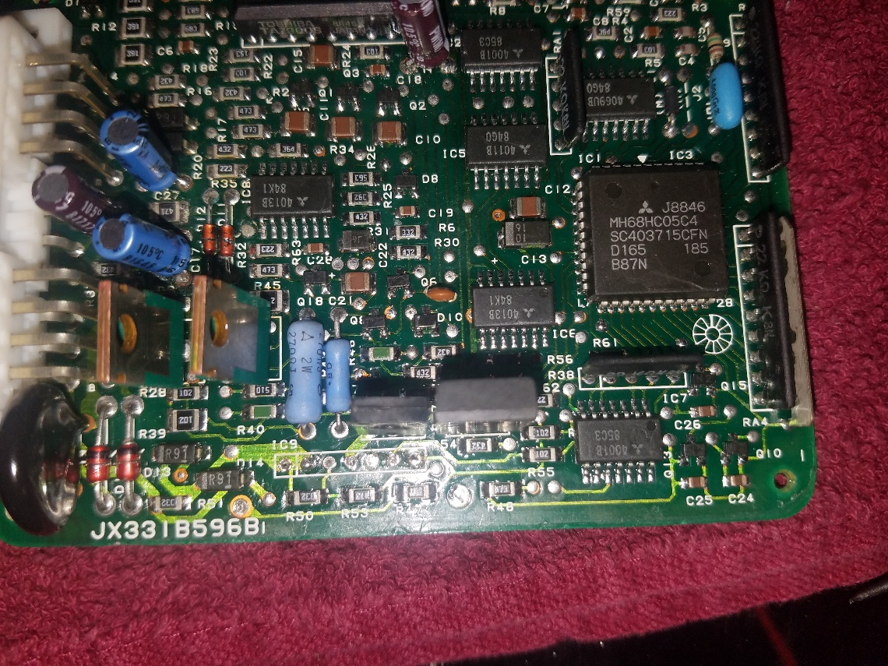
Figure 5 Circuit Board Top

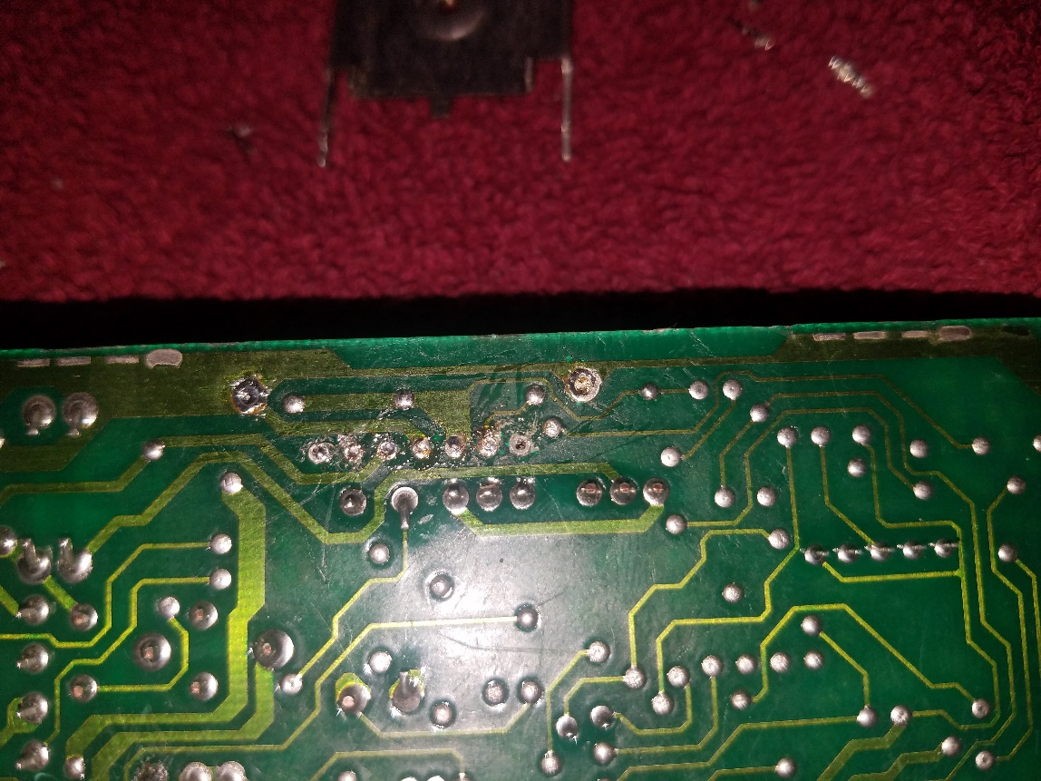
Figure 6 Circuit Board Bottom

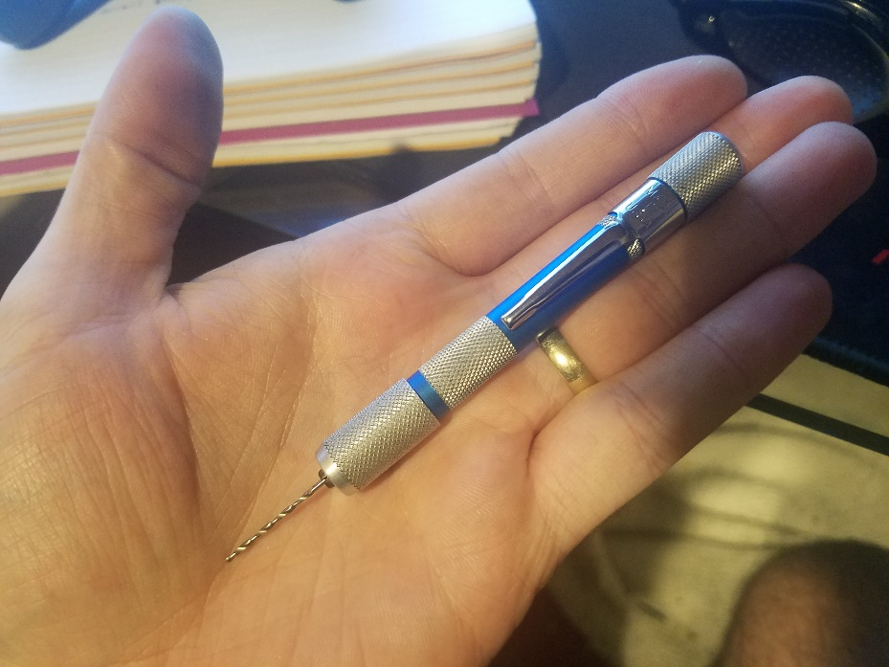
Figure 7 Watch Drill

Once holes were broached to the appropriate size for the respective pins, preparation of the pins was performed. A small amount of solder was added to the pins of the IC chip before installation. This was to ensure that solder would get to the proper locations because a soldering iron could not properly reach. The IC chip and heatsink were re-soldered and screwed together. A multimeter was used to inspect the connections of each of the pins to their respective components further away in the circuits. Inspection found satisfactory connections with the surrounding components, and that the short between pins b and t were no longer easily continuous.
While the unit was open, electrolytic capacitors were replaced as well, and the connections inspected in the same manner. All electrolytic capacitors were replaced with 105°C rated capacitors
Electrolytic capacitors used:
10V 47µF Digikey # P14478-ND
25V 4.7µF Digikey # 493-11353-1-ND
25V 47µF x2 Digikey # 493-4653-1-ND
50V 4.7µF Digikey # 493-11322-1-ND
Once the capacitors were installed, the unit was reassembled and reinstalled in the vehicle. Unit diagnostics were performed again, and no errors were found. Unit functions as intended.

