FC Fan Amp Troubleshooting and Rebuild
5/3/18
The following is a rebuild description for a repair of the FC Rx7 Fan Amplifier Circuits performed this past week. It covers the rebuild of the Fan Amplifier Board, as well as describe the replacement of the fan power transistor. The author forgot to take pictures of the power transistor replacement, so that will be described in text only.
Problems prior to repair: Intermittent to eventually dead blower fan, missing portions of fan control slider range, inconsistent gradient across slider range, lack of heat/cooling.

Replacement of Blower Fan Power Transistor
Factory Service Manual Pages U11-13, 30-33
The blower fan in the FC Rx7 is a DC motor that has two upstream power controls. The first power control is the power transistor. This transistor is used to throttle voltage to the blower motor when the slider is in between the off and full throttle position. When the slider is off, no voltage is supplied to the blower, and when the slider is maxed out, the fan relay is engaged, providing a solid voltage feed. The power transistor is under a lot of load, and especially at risk of failure if the amplifier circuit that controls it is not working properly.
The fan power transistor can be accessed by first removing the fan housing from behind the glove box. The fan housing should be held together by 3 or 4 spring clips, and a screw. Remove these, and the two halves of the housing should easily separate. After separating the housing, remove the two screws holding the thin metal separation plate in place. At this point, the transistor assembly should be accessible. Two screws should remove this assembly from the housing.
From the outside, the transistor assembly should look like an aluminum heatsink on one side, and a plastic clamshell on the other, with 3 spade connectors poking out of it. Remove the fasteners for the plastic clamshell, and it should pull straight off the spade connectors. With this removed, the soldered terminals for the transistor should be visible. De-solder the spade connector assembly and remove. This will expose the thermal fuse which is fastened to one of the machine screws affixing the transistor. Photograph the orientation for quick reassembly and remove fasteners and thermal fuse. At this point, the transistor should be loose and can be removed from the heatsink. Clean heatsink contact area and install new transistor. Reassemble in reverse order. The components can only go back together one way easily. A picture of the necessary transistor can be seen in Figure 1.

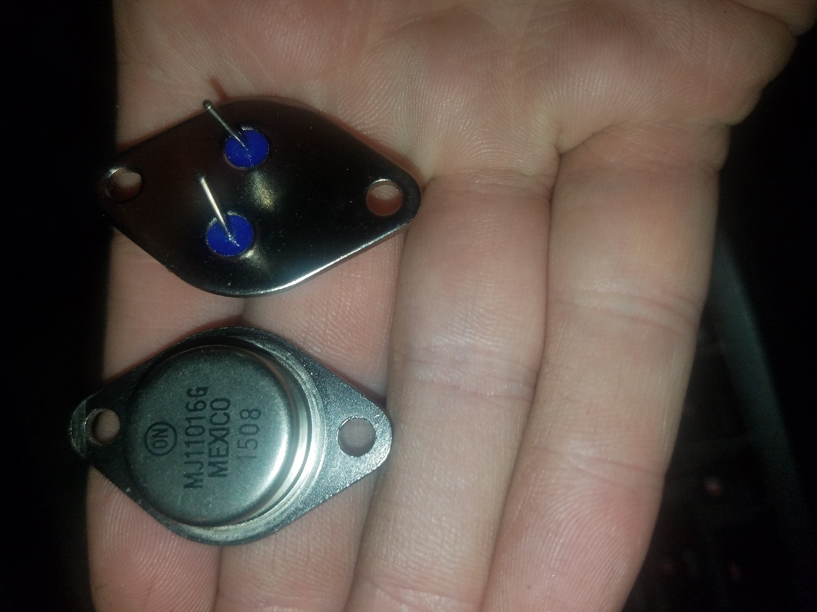
Figure 1 Fan Power Transistor Top and Bottom

Fan Amplifier Circuit Repair
Factory Service Manual Pages U29
Rebuilding of the fan amplifier circuit is discussed in the Rx7 Club post: https://www.rx7club.com/2nd-generation-specific-1986-1992-17/s5-logicon-amp-components-capacitor-cap-transistor-ic-dip-1105069/
This post lists the various equivalent capacitors and transistors that comprise the board. For some of the components listed as obsolete, they can be currently obtained from ebay, primarily the transistors. The cost for shipping comprises the majority of the overall cost for this rebuild. Because of this, be sure to inspect remaining components for failure as well. Figure 2 shows the top view of all the components for the fan amplifier board. This is probably the simplest board of all the circuit boards in the FC Rx7. All the components are arrayed in the same orientation and almost in rows as well. This makes it easier to keep track of tested components. Components that should be replaced without question are capacitors and transistors. The IC chip can be replaced as well, but if the circuit works after the rest of the rebuild, that probably isn’t necessary.
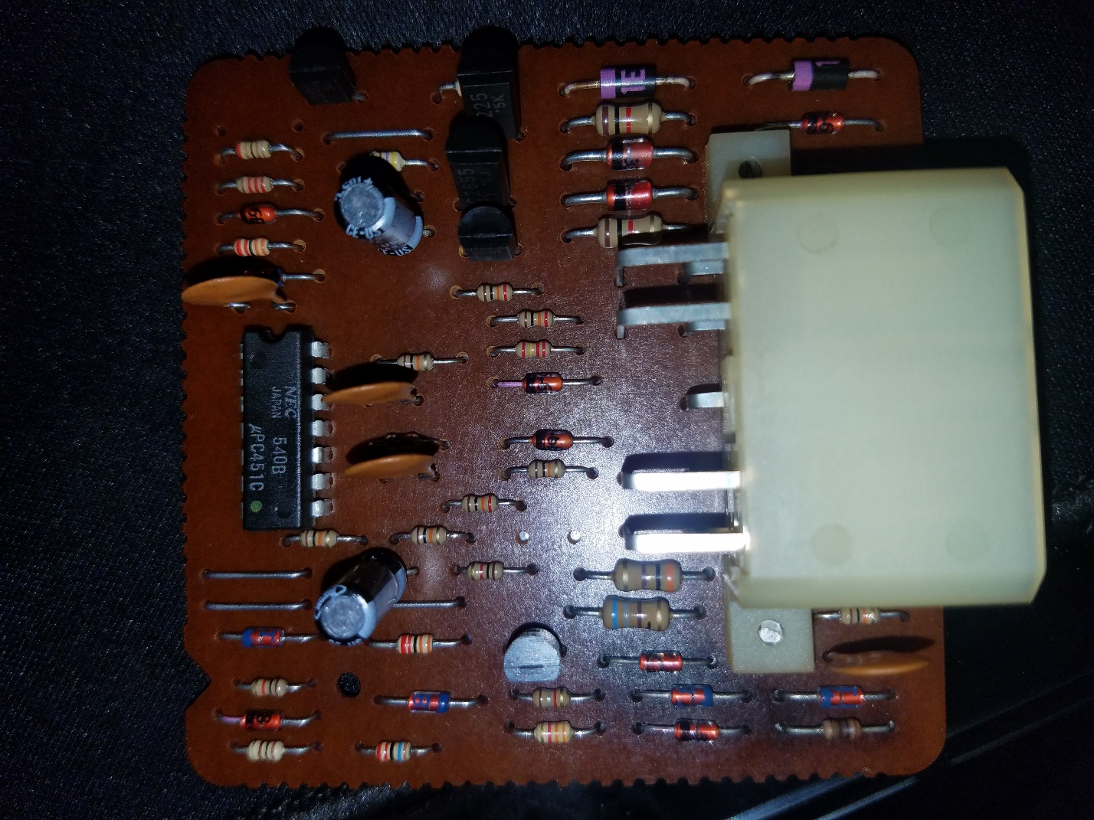
Figure 2 Fan Amplifier Circuit Board
After replacing transistors and capacitors, remaining components consist of diodes and resistors. Resistor values can be decoded easily using this calculator http://resistor.cherryjourney.pt/. When testing resistor and diode components, one end of each component should be de-soldered and remove from the circuit before testing. This prevents errant readings. There are plenty of components to test here (you probably don’t need to test the bridge wires), so a good, adjustable temp soldering iron, and some tunes are going to be needed. Testing these components can be accomplished using a multimeter to read the appropriate values of the resistors and checking the function of the diodes. Diode components can be tested by checking resistance in both directions. One direction should have a resistance around the range of 600-800ohms, and the other direction should show no continuity (infinite resistance). Components that are out of compliance should be replaced. Do inventory of these items before ordering electronic components because shipping on the individual packages can get expensive.
In the case of the amplifier circuit in Figure 2, all capacitors and transistors were replaced with the appropriate replacements. The two circled components, a transistor and a diode were no longer functioning properly. Both components had failed and created an open circuit. This explains the failure of the slider switch to adjust fan speed properly, as well as increased failure rate of fan power transistors. Resistors all tested within range, so they remained original. The IC chip was not replaced either. Unit was reassembled and reinstalled into the vehicle along with fan assembly. After installation, the fan was turned on and tested across the whole operating range. The fan speed increased smoothly and linearly across the entire range of the slider, with the fan relay engaging at full speed.
This is one of the simplest circuits to repair in the FC Rx7 compared to the other controllers and computers. It is good practice for novice soldering and if you are going to do other circuits in the car, start with this one. This also fixes a common nuisance and makes driving the car more pleasant. It was definitely a worthwhile fix.

