(DRIVETRAIN) GSL and SE LSD teardown pics,drivetrain tutorials coming soon (http://www.rx7club.com/1st-gen-archive-71/drivetrain-gsl-se-lsd-teardown-pics-drivetrain-tutorials-coming-soon-717591/)
steve84GS TII | 11-26-07 07:46 PM

(DRIVETRAIN) GSL and SE LSD teardown pics, drivetrain tutorials coming soon
OK, after a couple years of just driving and not working on my car, I’ve got the bug again and am tackling some drivetrain issues that have cropped up recently. Namely my noisy TII trans and changing rear-end ratios. I scored a very clean TII trans last week with low miles and will be prepping it for install. My old TII will get repaired and will come up for sale, already modded for a 1st gen. I also have a handful of 3rd members that I will be tearing down to spec out the best parts and rebuild with new bearings and a change to 3.96 gears.
Over the next month or so, I’ll be performing and documenting (with my new camera) the steps needed to......
Modify a TII trans for a 1st gen install.
Rebuild an LSD and/or change your side gears for the 84-85 axles.
Rebuild, setup a 1st gen rear-end.
These will be more or less step by step. I’ll photograph and describe the specific, technical stuff. I don’t have the patience to photo and go into depth on every single step, but if you are attempting some of these jobs on your own, you should already know how to drop a tranny, or remove a rear axle.
As a preview to these upcoming jobs, here’s a few pics of what I found inside two of my diffs. One is the 3rd member from my custom GLC axle I had made long ago using an 81 GSL unit. The other is the original LSD from my GSL-SE axle that I ran for years behind the TII engine.
GSL limited slip parts.
At left are the cone spring and thrust washer, next over are the drive discs and at far right are the driven discs. Note that there are equal numbers of drive and driven discs. Also, I found that when compared to Dana Spicer 44 LSD plates, they are quite large for the size of the carrier that they come from. It’s no wonder our LSD's are often well in spec after 20+ years, providing the oil is changed. These came from my V-6 GLC rear-end and are in near perfect condition. They had lots of miles and had to contend with a torquey little V-6, plus the previous miles of the donor vehicle.
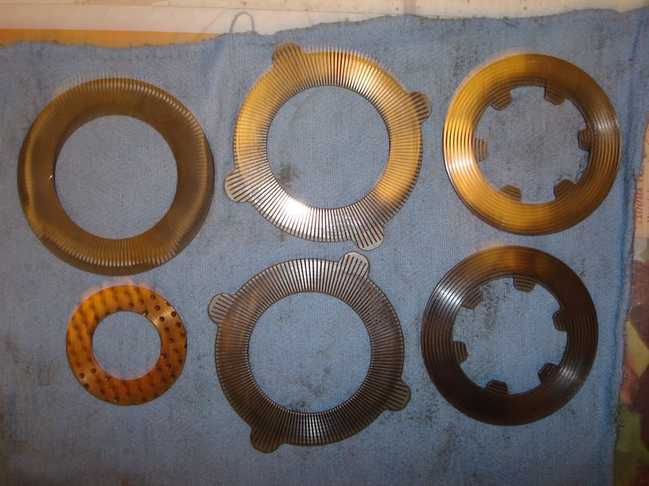
GSL-SE limited slip parts.
Notice first that there are an equal, total number of friction discs, however only ONE of them is a driven disc. The others are drive discs. On the outside of the stack, there are actually two drive discs packed next to each other.....doing NOTHING. The lone driven disc is left to do all the work and sadly that disc and the adjacent drive discs were well worn and a bit blue. They did after all have to live behind my 13BT for a long time, had to endure my drag strip sessions back then, and they had 100K miles on them before I installed the unit.
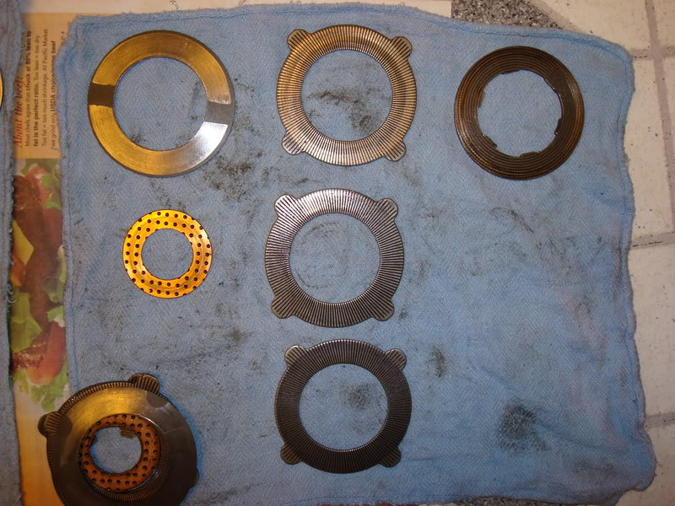
Here’s what I didn’t notice right away........ The lone, driven disc on the right side of the diff actually had its drive tabs sheared off! Having to work by itself was too much and it failed. The other side was OK, since once the right side failed, there was little to no LSD action left. How it ever worked, or when it failed is unknown, but this clearly documents the weaker nature of the GSL-SE LSD unit.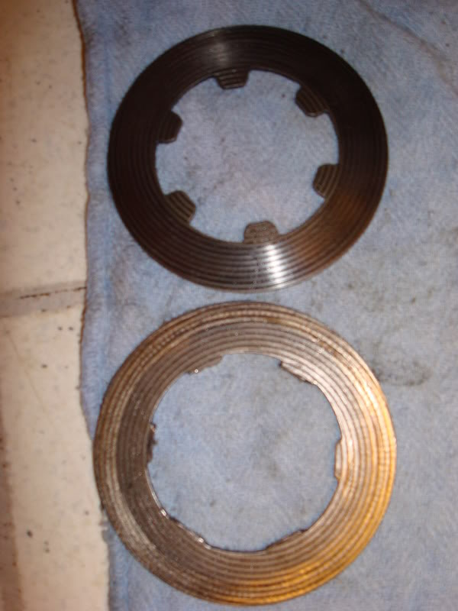
More to come in later threads as I get the time and so long as the weather holds out!

steve84GS TII | 11-26-07 08:33 PM

I wont be pulling the tail shaft, no need for it when doing the 1st gen mods to the TII trans. The write-up will cover the mods to the shifter housing and my approach to making a simple cross member.
I’m 99.9% sure my old TII trans just needs an input shaft pocket bearing, so I wont be doing a full teardown of that unit either. Every other aspect of that tranny still works fine, which is why I’m gonna sell her off.
Doing tranny work really requires that you either document well, or re-assemble soon after so that you don’t forget stuff. I’ve yet to tear all the way into a rotary trans, but units that I have done typically don’t call for removing the tail shaft from the main shaft assembly unless you are doing a full rebuild (syncros, pocket bearings, etc.)

steve84GS TII | 11-26-07 09:34 PM

On the GSL yes, as the first pics shows.
On the SE, there are 3 drive and only one driven. This fact has been covered in the past, I’m just providing pics and experience.
The only reason I can see for making the SE's LSD more tame would be to reduce the chance of the rear-end side-stepping under the increased power and lower rear-end ratio, that the SE posses. It’s not a wildly powerful car, so LSD longevity is not an issue, but the 1st gens tail happy nature was well known and the torquey SE 13B would have made it worse if the LSD were very grabby.

steve84GS TII | 11-27-07 12:09 AM

It won’t be down long actually, since I have enough spares to do it all at my leisure.
The tranny mods and swap will only take a day or two, without rushing.
The rear-end I can build entirely with my spare units. I have bearings on order and enough gear sets and LSD parts to pick and choose the best pieces. Then it’s just remove and replace......a few hours tops for the rear-end swap.
I’ll be ordering new cone springs from Mazdatrix just to be sure, but I have lots of good LSD plates to use. Bearings will be Timken units from Napa....far cheaper than Mazdatrixs' price and I trust Timken since that’s all I use in my rock crawler.
I will be documenting the rear-end setup in regards to the lash, pattern and pinion preload settings.
In the meantime, here is a link that is very relevant and can be used as a handy guide for setting up all types of diffs, including Japanese 3rd members, like ours......
http://www.pirate4x4.com/tech/billav...structions.pdf

REVHED | 11-27-07 01:57 AM

I highly recommend machining the left LSD case if you want to tighten things up a bit. Mine was on the weak side with very low break away torque but on disassembly everything was still well within spec. I took .5mm off the case and it tightened things up nicely. Breakaway torque is now up around the 100ft/lb. mark which is a bit more than what it was new from the factory.

j9fd3s | 11-27-07 06:47 PM

Quote:

Originally Posted by REVHED (Post 7554748)
I highly recommend machining the left LSD case if you want to tighten things up a bit. Mine was on the weak side with very low break away torque but on disassembly everything was still well within spec. I took .5mm off the case and it tightened things up nicely. Breakaway torque is now up around the 100ft/lb. mark which is a bit more than what it was new from the factory.

I've seen that too, the case wears out where the spider gear shafts go thru it. When it gets really bad, it gets clunky on decel....

steve84GS TII | 11-27-07 09:57 PM

I’ll be taking all measurements as the build progresses.

There are 4 measurements taken that will give you wear specs on the inner core and outer carrier where the end discs and thrust washers rub.

The factory cure is to install thicker thrust washers which will push the LSD core into heavier contact with the clutch packs and springs, taking up the slack and achieving the same results as machining the case.
As of now, I’m in VERY good shape in regards to disc specs.
All the discs from my GSL unit measured between 1.96mm and 1.98mm thick.

Brand new they are 2.00mm and the limit is 1.90mm,so that’s VERY little wear at all.

The thrust washers measured 1.55mm with a new thickness of 1.60 and a minimum of 1.40mm,so that’s also promisingly little wear.

Neither side of the carrier had any substantial wear or steps in the thrust surface, nor did the spider core case.
Even just one 1.80mm, oversize thrust washer would put me over the new specs, so I’ll be leaving that alone barring any out of spec numbers once I measure the stack installed in the carrier. A set of new cone springs and I should be all set.
I’m actually going to replace the two thinnest drive discs (1.96 and 1.97) with a pair from my worn SE unit......why?......because the very outer left and right drive disc in the SE unit, are flanked by the case, and another drive disc. This means they NEVER spin against anything for their entire life!
Indeed, both extreme outer drive discs measured 2.00mm and had nary a scratch after I cleaned and inspected them. If I use them to replace my two most worn discs in the GSL unit, I’ll pick up another .07mm of thickness and be only .04mm below spec, for a brand-new unit.

REVHED | 11-28-07 07:34 AM

Quote:

Originally Posted by j9fd3s (Post 7557280)
I've seen that too, the case wears out where the spider gear shafts go thru it. when it gets really bad, it gets clunky on decel....

I was talking about machining the left case flange to obtain more crush on the clutch pack. But now that you mention it I've got a bit of a clunk that I've been trying to diagnose. What causes the wear on the shaft surface? Obviously there's no way to fix it.

steve84GS TII | 11-28-07 10:50 PM

rear-end lash that is not attributable to the ring and pinion can only be from two other places......
1st......The axle shaft/side gear splines.
This is obvious since the splines are easily inspected.
2nd.....The spider "core" of the LSD.
This can induce a lot of lash because there are multiple wear points including the bevel gears themselves, the 4 spider pins, the ramps on the pins and thrust blocks. Ramp wear will usually occur on the "drive" side of the ramps since there is usually more torque coming from the engine than back up the drivetrain from the wheel, like when letting off the throttle abruptly. Since its unlikely you’ll ever find a brand new set of gears, spider and/or thrust blocks, its best to probably fish around for a lower mileage LSD to replace the one you have. Worn discs will not induce lash since they don’t actually transmit any torque, they just help to keep both wheels spinning at the same speed when torque is applied.
Here’s a shot of the spider pin ramps. Ramps on both sides means the LSD will lock on accel and decel. The angle of the ramps when the unit is designed will determine the abruptness of lockup. The ring gear turns the carrier, the carrier is locked to the thrust blocks you see poking through the left side hole. The thrust blocks bear against the 4 round spider pins via the ramps, the spider turns the 2 spider gears, which turn the side gears that are splined to the axles. Any wear, anywhere inside the core of the diff will cause lash between the axle shafts and the ring/pinion.
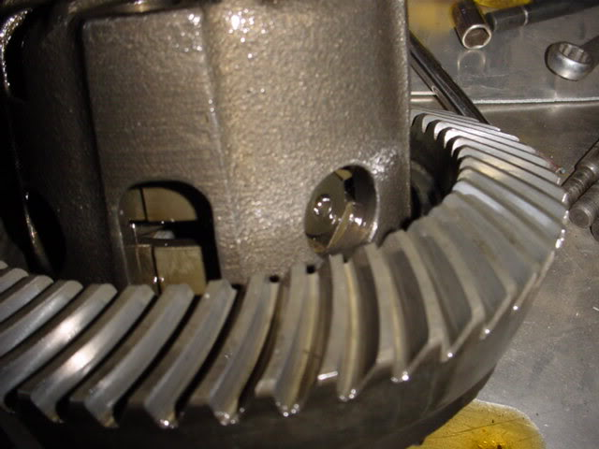
I’ve seen Jeep diffs so worn out internally that you could turn the driveshaft over 1/4 turn and the wheels would not move.....and the ring/pinion backlash was fine!
The ideal, aggressive LSD will be from an 81-85 12A car, regardless of what it goes into. Just be aware that the side gear splines changed in 84,so you would have to mix and match parts if your car is older. I’m using my GSL-SE spider core with its bigger axle splines, then my 81 LSD plates and carrier for their greater locking ability.
The GSL-SE LSD is identical in all respects except that the disc stack is laid out so that the LSD is less grabby. Even increasing clamp load will not change the fact that there are only 2 friction surfaces on each axle (2 per driven disc), rather than 4 on each axle in the GSL.
Drifting is hard on ALL drivetrain components, in fact it’s hard on EVERY part of the car. Extreme lateral stress on everything, extended high HP application, relatively low vehicle speeds, lots of clutch popping, etc. Anytime you’re turning and spinning both tires, any LSD will have to slip at some point, which is when the discs will wear. If there is a lot of torque going into the LSD at the time, then clamping loads will be at their highest, which means friction will be at its highest and that makes HEAT!
A locker, spool or welded diff is the only way to not generate excess heat in a diff when drifting. But a locked rear-end would probably be dangerously hard to control and predict since there is NO give at all.....snap oversteer anyone?!

vipernicus42 | 11-28-07 11:00 PM

This is working up to be a thread full of win and awesome.
What I'd *really* like to know (but may not be within the scope of your transmission repairs) is how to change the speedo gear, if that's possible.
The reason being that if you start playing with gear ratios like putting in a TII trans or changing the rear gear ratio, your speedometer reads incorrectly. If there's a way to make the speedometer read stock after installing a TII tranny and upgrading the rear gear then I'd be a helluva lot more likely to do it.
And heck... I might even be tempted to buy your old TII trans and one of your LSD rears and ship the damn things up to Canada ;)
Jon

steve84GS TII | 11-28-07 11:11 PM

Changing the speedo gear isn’t hard, it’s the application that is hard. It’s an obscure vehicle and no one ever really NEEDS to change the speedo drive ratio. Finding a bigger or smaller gear to fit our trannies would be a trial and error process. It has to fit the output shaft OD, mesh with the driven gear's pitch and of course be a different size than the stock gear!
Jeeps and such need that all the time because lift kits, tires and gear changes are the norm for them. There are lots of speedo gears available for 4x4's, they are color coded by ratio. We probably will have to hit the yards and start filling our pockets with little plastic gears, to try out!
That said, my speedo is dead-nuts-accurate with a TII tranny, 4.07 gears and my 17" tires. The taller 5th gear is cancelled out by my slightly shorter rear-end ratio and my tires while 17", are only 35 series, so the circumference is close to stock. The TII trans 5th gear ratio is almost the same as an SE trans 5th gear, so if you run an SE rear-end ratio, the only thing that will alter speedo accuracy is the tire size.

REVHED | 11-29-07 01:52 AM

When I had 4.44's on my old car I had a ratio box made to correct the speedo. It's just a small gearbox that bolts in between the speedo cable and speedo drive.

REVHED | 11-29-07 01:56 AM

Quote:

Originally Posted by steve84GS TII (Post 7563493)
Rear-end lash that is not attributable to the ring and pinion can only be from two other places......
1st......The axle shaft/side gear splines.
This is obvious since the splines are easily inspected.
2nd.....The spider "core" of the LSD.
This can induce a lot of lash because there are multiple wear points including the bevel gears themselves, the 4 spider pins, and the ramps on the pins and thrust blocks. Ramp wear will usually occur on the "drive" side of the ramps since there is usually more torque coming from the engine than back up the drivetrain from the wheel, like when letting off the throttle abruptly. Since its unlikely you'll ever find a brand-new set of gears, spider and/or thrust blocks, its best to probably fish around for a lower mileage LSD to replace the one you have. Worn discs will not induce lash since they don't actually transmit any torque, they just help to keep both wheels spinning at the same speed when torque is applied.

Thanks, that makes sense. I was almost going to pull the diff out to recheck the backlash.

j9fd3s | 11-29-07 12:33 PM

Quote:

Originally Posted by steve84GS TII (Post 7563612)
Changing the speedo gear isn't hard, its the application that is hard. Its an obscure vehicle, and no one ever really NEEDS to change the speedo drive ratio. Finding a bigger or smaller gear to fit our trannies would be a trial and error process. It has to fit the output shaft OD, mesh with the driven gear's pitch and of course be a different size than the stock gear!
Jeeps and such need that all the time because lift kits, tires and gear changes are the norm for them. There are lots of speedo gears available for 4x4's,they are color coded by ratio. We probably will have to hit the yards and start filling our pockets with little plastic gears, to try out!
That said, my speedo is dead-nuts-accurate with a TII tranny,4.07 gears and my 17" tires. The taller 5th gear is cancelled out by my slightly shorter rear-end ratio and my tires while 17",are only 35 series, so the circumference is close to stock. The TII trans 5th gear ratio is almost the same as an SE trans 5th gear, so if you run an SE rear-end ratio, the only thing that will alter speedo accuracy is the tire size.

http://members.aol.com/solomiata/Drivetrain.html near the bottom he lists the stock speedo gears, seems like there's enough selection to accommodate the sane people...

“SPEEDOMETER GEARS:
The speedometer gears and gear housings between all the late model(1984+) 'M' transmissions interchange. If you have installed different rear ratio gears or different diameter tires then you will need to change the speedometer gears in the transmission to keep the speedometer accurate. The speedometer gear housing bolts to the transmission and is easily removed since it is external to the transmission
Mazda makes speedometer gears for the late model 'M' transmission with 17-23 teeth. The steeper the rear ratio gears or the shorter the tire diameter the more number of teeth is needed to compensate. The 90-91 Miata comes from the factory with a 20 tooth speedometer gear (which makes the 4.30:1 gear about 5mph fast). The pitch of all the speedometer gears is the same and only the diameter of the gear is different (1978-mid83, with the exception of the 626, use a coarse drive gear and are not interchangeable). The different gears housings are offset to account for the diameter change (see picture)
Speedo gear chart
Car | tooth count | gear color | notes
84-85 12A RX-7 | 17 | green | '79-83 coarse gears
84+ B2000/2200 truck,  84-85 13B GSL-SE RX-7 | 18 | purple
86-91 RX-7 convt | 19 | red (small diameter)
90-91 Miata, 86-91 RX-7 | 20 | black
1989-90 RX-7 GTUS | 21 | white | 4.30:1 rear ratio
1979-82 RWD 626 | 22 | Red
92+ Miata | 23 | Red
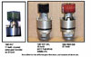
FYI, If you cannot find a 626 or late model Miata unit then you can make one by using the abundant 1979-83 RX-7 17 tooth coarse gear drive, which is the same diameter as the 22 and 23 tooth fine tooth drives. This makes the housings interchangeable and then only the drive gear itself (22 tooth = part number 8854-17-441A) needs to be purchased.
Special thanks to John Sisler and MazdaMart for providing the info and picture. See also Felix's speedometer gear interchange page for more info.”

vipernicus42 | 11-29-07 01:44 PM

So if I understand it right, the only things that affect the speedo gear are the rear gear and the tire circumference. The gear is driven at the same speed as the driveshaft, so the gears inside the tranny don't affect it. They only affect the difference in speed between the flywheel and the driveshaft.
So does that mean that with a TII tranny and a stock rear end I could just swap the speedo gear from my stock tranny and be done with it?
Of course I'd probably figure out the math and get a speedo gear to match a higher rear end gear ratio, but I just want to know if I'm on the right track.
Jon

steve84GS TII | 11-29-07 09:46 PM

Your right, momentary lapse of brain power there.
The gear ratios in the trans only determine engine RPM relative to vehicle speed for a given gear. Since the speedo gear is on the output shaft, only rear-end gear ratio and tire size will affect speedo accuracy. And of course, the ratio of the speedo gears themselves will affect it.
Got all my parts clean and ready tonight.
I’m starting the assembly and measurement of the stack right now to determine if there is any case wear. Pics to follow.......

steve84GS TII | 11-30-07 12:18 AM

Alright, here we go with the assembly and measurements for the LSD rebuild.......
As expected, I’m well in spec. Things were looking quite good outright and nearly all my discs were in like new condition. This setup ought to be quiet, smooth and plenty grippy.
First step is to lay everything out in order. Here is the entire differential assembly in the order its assembled. You can see the spider at the center, spider gears, the side gears, thrust blocks and case halves. The LSD discs go between the thrust blocks and case halves.
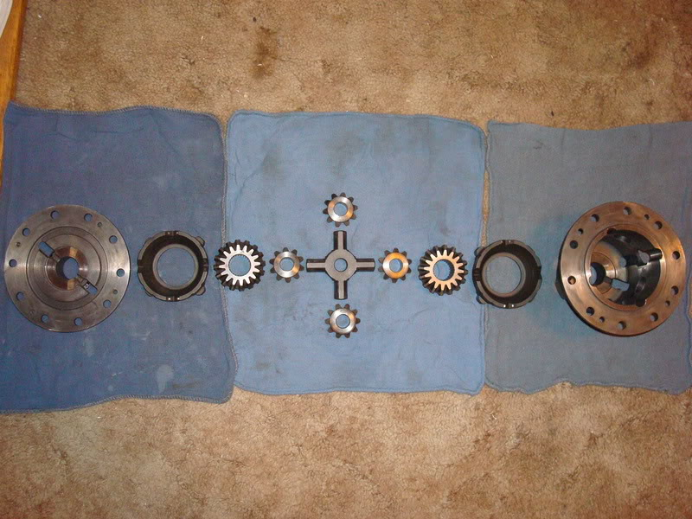

Here are the drive portions of the diff within the carrier unit. The outer case, thrust blocks and drive discs all have corresponding tabs that lock together and rotate them as a unit.
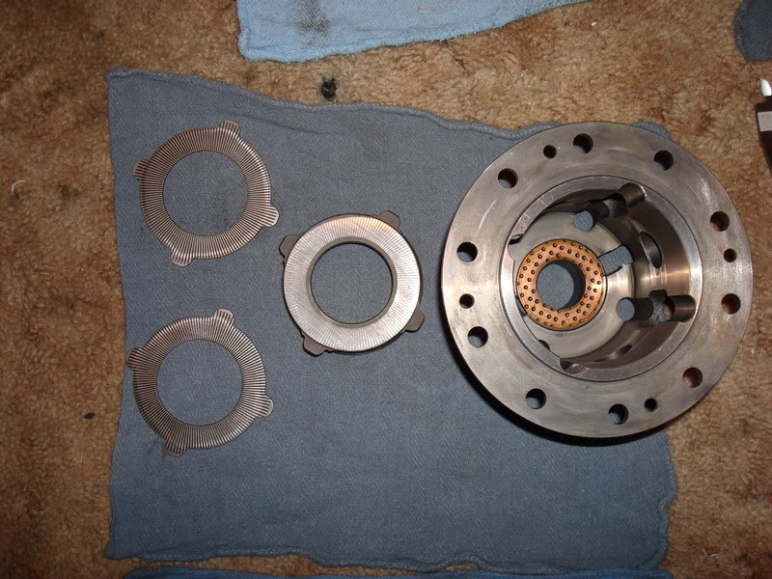
Here are the driven portions that are part of each axle shaft. The side gear is splined to the axle and the driven LSD discs have tabs that engage the side gear which makes them all spin as a unit.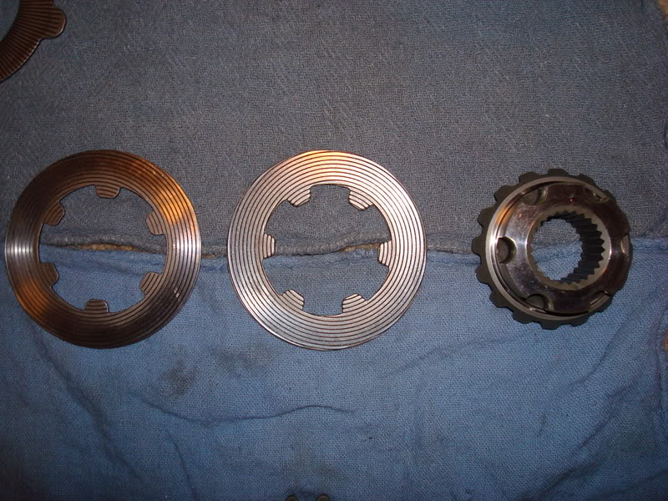
Here you can see the ramps on the thrust blocks and the spider. If you look close, you’ll see that one side of the spider has heavier wear and the other has lighter wear. This is also visible on the bottom ramp of the thrust block. The heavy side wear is input torque from the engine and the light wear side is caused by coasting torque from the wheels. The wear marks can help you to determine which side is which should you misplace the thrust blocks or get the spider flipped over backwards.
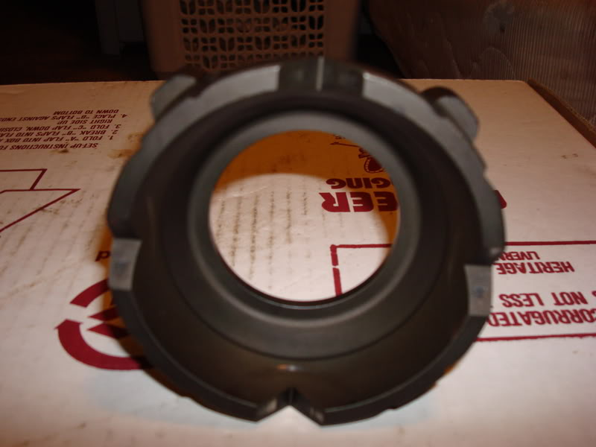
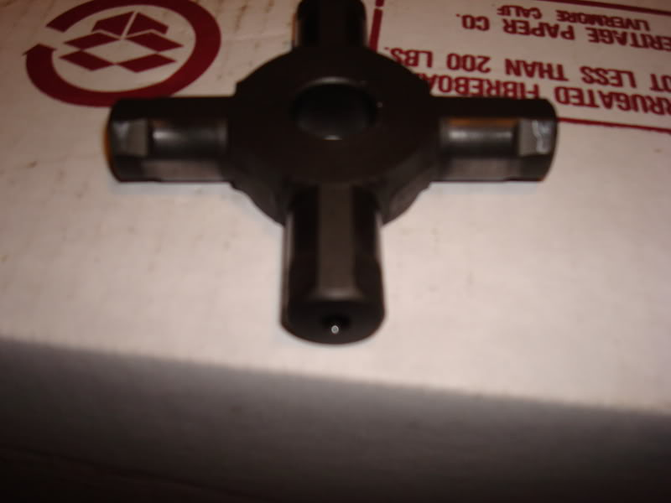

Step 1 is to determine the clearance you have inside the case for the LSD core.
It can be anywhere from 0 to .20MM standard clearance with a maximum gap of 1.0MM.
First measure the thickness (not the height) of each cone spring and record it. Then measure the width of the LSD unit with all the discs installed...measure to the outer side of each end disc and be sure to hold everything tightly together. I took 4 measurements from all around the discs and averaged them. Here's what I got.....
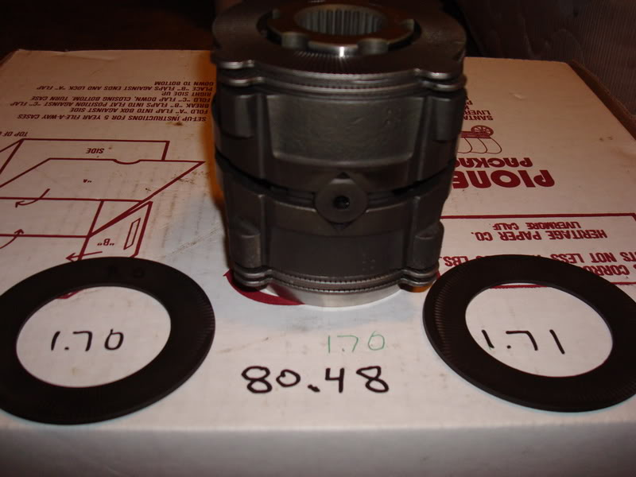
The carrier case inside width will not change or wear because the point where the factory measures it is behind the cone springs and they do not move relative to the carrier, so no wear is possible.

The carrier width is 84.0MM, so you take your LSD core width, add the width of the cone springs and them subtract that number from 84.0MM.......I got .11MM total clearance, which means that each cone spring is within .055MM of being totally crushed flat when the LSD is assembled.....that about as much preload as can be obtained provided that the cone springs are in new condition.
Step 2 coming up.........

steve84GS TII | 11-30-07 12:53 AM

Step 2 involves measuring the LSD core with the copper thrust washers installed.

Too much clearance will induce slop in the spider gears since they are beveled and gain lash as they spread apart from each other. The thrust washers bear against the side gears and put them into contact with the spider gears.
They do no affect the LSD preload tension as I incorrectly stated when REVHEAD mentioned machining the cases. Thicker LSD drive discs are available for taking up excess play in the previous procedure. For this part of the assembly, if the tolerances are outside of spec, you can get thicker thrust washers to close up the slop in the spiders/side gears.
First measure the width of the LSD unit including the thrust washers. I took several measurements and backed them up by measuring the LSD assembly and the washers separately and then adding the 3 values. I averaged them all for a width of 87.81MM. The factory spec is 88.2MM. You then subtract your measurement from that number and get your clearance.....mine was .39MM of clearance. The factory spec range is .16 to .42MM so I'm within spec, although a tad loose. No biggie, since the max allowable clearance is .80MM which I am far from. Oversize thrust washers can be used to take up the wear or you can install better or buy new spider gears to get rid of the slop without the thicker washers.
Now for assembly.........
First lay the right side thrust washer and cone spring inside the carrier case.
Then stack the 4 LSD discs starting with an outside spline disc and ending with an inside spline disc.
This will give you the maximum friction surfaces allowable with 4 LSD discs on each side.
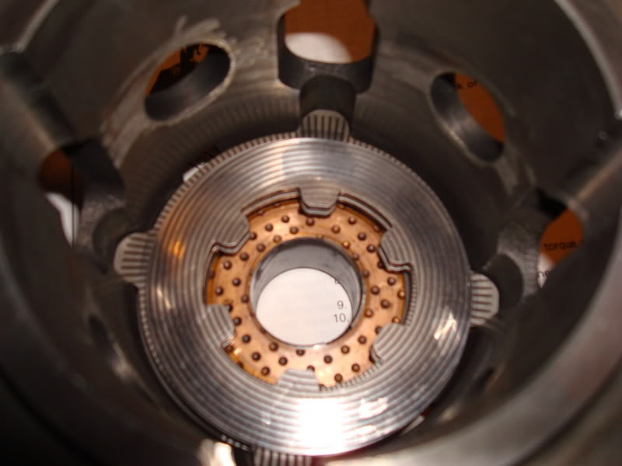

Then install the thrust block over the discs.
I found it easier to first align the driven discs with a side gear before installing the thrust block.
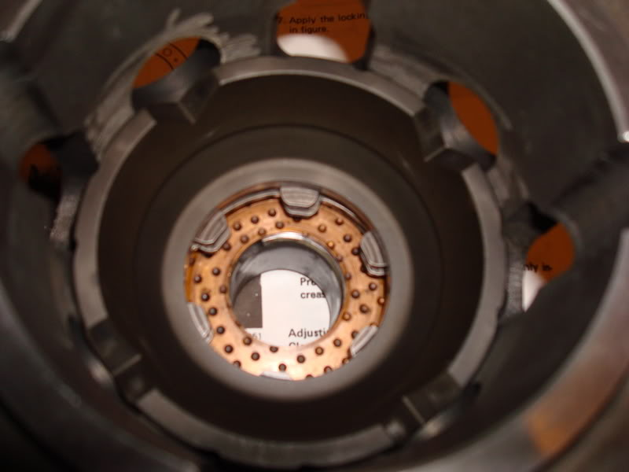
Then, install the side gear into the block, engaging the gear's splines with the driven discs.

Then you can drop the spider and spider gears into the block and engage all the gears together.
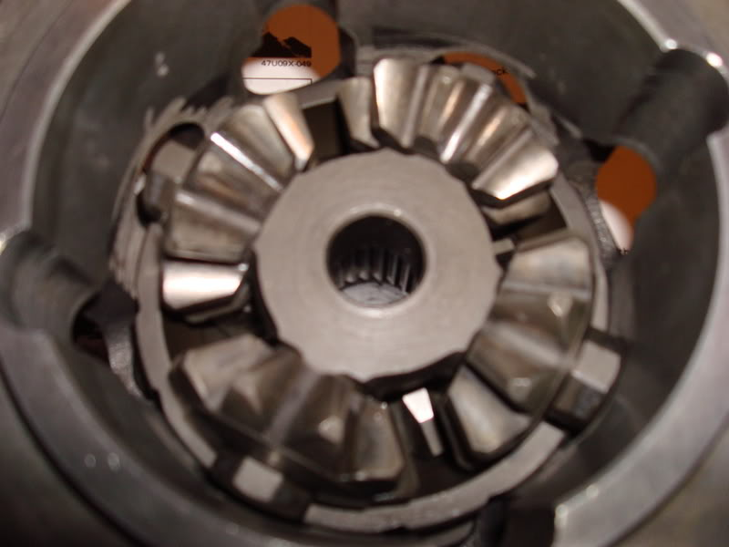
Your now halfway there. Just install the other side gear, thrust block and 4 LSD plates, starting with an inside spline disc and ending with an outside spline disc.
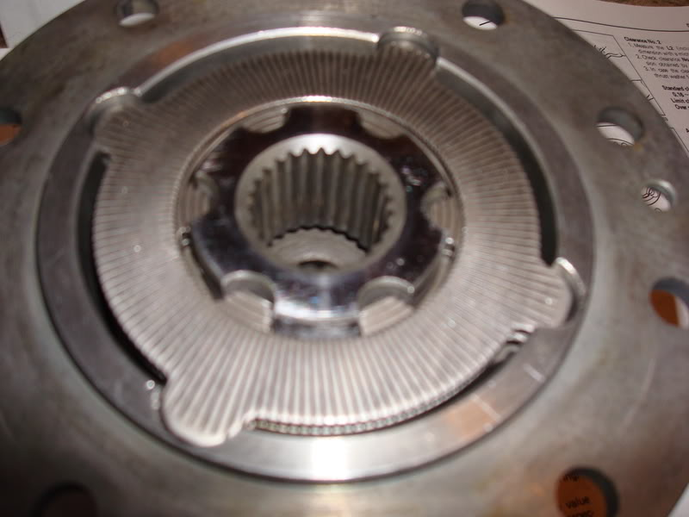
Now install the other cone spring and thrust washer on the pack.
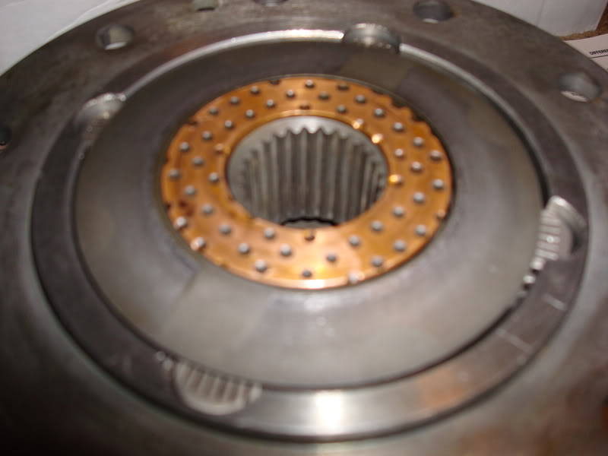
Once the end cap is in place, line up the ID marks on the circumference of each and loosely screw in the 4 little Phillips screw that hold the case together.
Before tightening, check that the thrust washers and cone springs are centered and aligned with everything. They can move around a little, but its unlikely they will get out of place. But still, better to be sure.
Then snug up the screws and you are done!
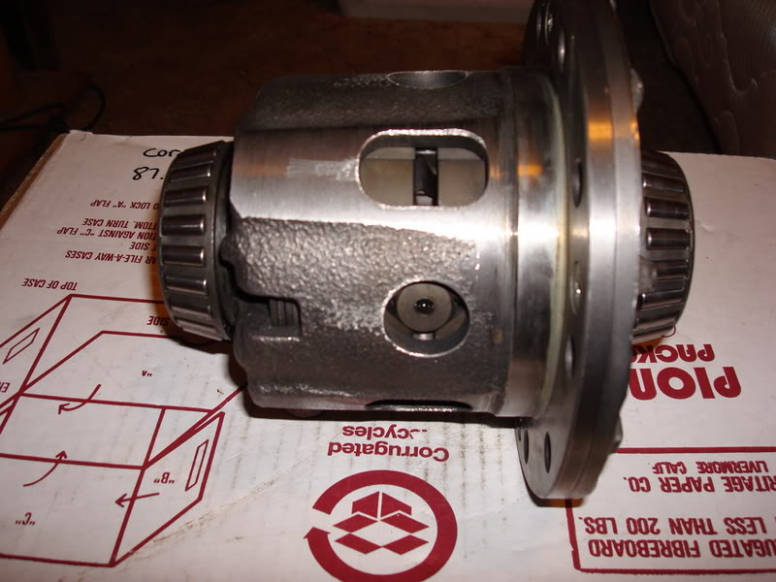
The next session will involve installing the gears and new bearings and setting up all the specs for pinion preload and gear backlash as well as checking the pattern.

Sgt Fox | 12-29-07 01:27 PM

Should you lightly lubricate the disks and gears with gear oil when you reassemble?

steve84GS TII | 12-29-07 08:27 PM

Ehh..........
If your going to be installing it right away, then it cant hurt. If its going to sit like mine did, then keeping it dry is cleaner and wont attract dust. Once the diff is installed and spun a few times, everything will be soaked down and lubed.
I hinted at putting this thread in the archives, since my gear setting thread is in there now. The two go hand- in- hand for anyone looking to do a full rear-end job.

granolavsrasins | 12-30-07 01:46 AM

quick question, what drive shaft is used with the t11 tranny and SE rear end?

steve84GS TII | 12-30-07 05:36 PM

Custom made.
Using a stock 1st gen shaft behind a TII is a bad idea, and the TII shaft is too short. So instead of trying to make a hybrid shaft to connect the two components, its better to just have a shop make a full custom unit from other factory parts.
By bringing in a TII front yoke and the SE rear companion flange, they can match up what new yokes will accept the same size tubing and cut it to length. I'm pretty sure they used Ford parts on both ends. Cost me about 200 bucks, nothing fancy and its plenty big, greasable and rebuild able.

(DRIVETRAIN) How To: Rebuild your LSD (http://www.rx7club.com/1st-gen-archive-71/drivetrain-how-rebuild-your-lsd-711948/)
steve84GS TII | 12-10-07 01:06 AM

(DRIVETRAIN) How To: Rebuild your LSD
OK kids, here's part 2 to go along with the LSD rebuild I outlined a couple weeks ago.
So, assuming you have the 3rd member out of the car already and have rebuilt your LSD, are adding an LSD to an open diff unit, or are changing gear ratios, here are the steps for rebuilding the entire unit.
You WILL need a few special tools a vice and a clean work space.
You do not have to own a press, although one will make things easier. Also, nearly all the special tools needed can be bought on a child's allowance from Harbor Freight......not that I advocate shopping there, but some items they sell do work fine and are dirt cheap. Here's a list of tools needed.
- Micrometer and magnetic stand. (cheaper than you might think)
- Vernier calipers. (digitals are great and are getting cheaper)
- Inch lb. torque wrench. (must be dial or beam "bendy" type)
- Foot lb. torque wrench. (I prefer "clickers" for the bigger stuff).
- Gear puller. (2 jaw, or bearing splitter type....or a small grinder and a steady hand)
First off, get the entire unit stripped down and clean. Lay out all the parts on a clean table and keep left and right stuff in place. The bearing caps for the differential MUST be kept in order, so mark or stamp them "R" and "L". Strip off all the old bearings using a puller, press or demolish them with a screwdriver and CAREFULLY grind a slit in the inner race until you can pop a crack in it with a hammer and chisel. They will pull right off after that, but I don't recommend this method because of the potential for damage and the grinding grit is thrown everywhere.....but it does work.
Here is the bare housing. A vice works well for holding it, just slip the fat rib at the bottom into the jaws and tighten.
Be sure EVERYTHING is clean, especially where the bearings slip in.
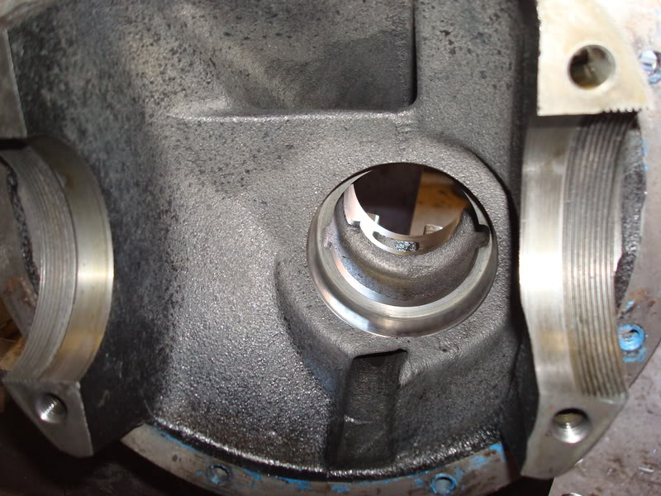
Here are the 4 bearings you'll need for the rebuild. They are NAPA parts and they are the same numbers as the stock Japanese bearings. These are German made, but Timkens will also work and are the same number. Much cheaper than the dealer or Mazdatrix, especially with my discount!
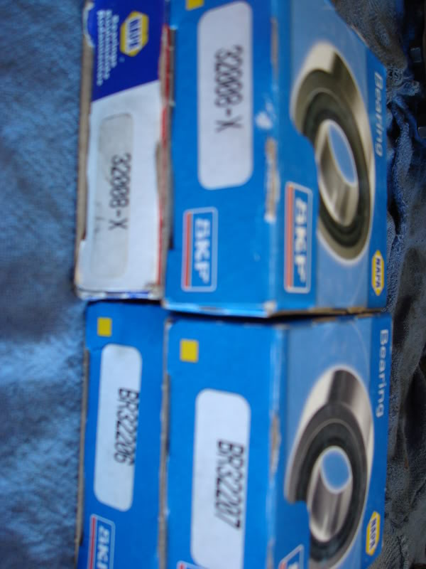
First, drive in the new pinion outer races with a hammer and punch.
Be careful not to slip and gouge the running surface, but be sure to seat them well. You'll hear and feel the difference when they seat.
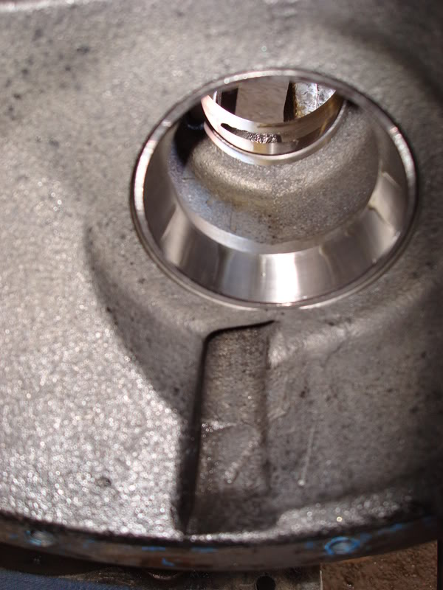
Next, we have the depth shim for the pinion, mine measured 3.11 MM.
These place the gears at the right position dependent on the housing you are using. Getting the right shim for a given housing requires a lot of special factory tools and measuring. If you use the shim that goes with the 3rd member housing you are using, then it should be close, regardless of what gears you install. If your just adding an LSD carrier or replacing bearings, then the original shim will definitely be the right one. 14 different shims are available in varying thickness', but repeated installs and teardowns are needed to get the right one if you don't have all the special tools needed......so if you have multiple 3rd members lying around, be sure to keep the pinion shims together with the housings they came out of.
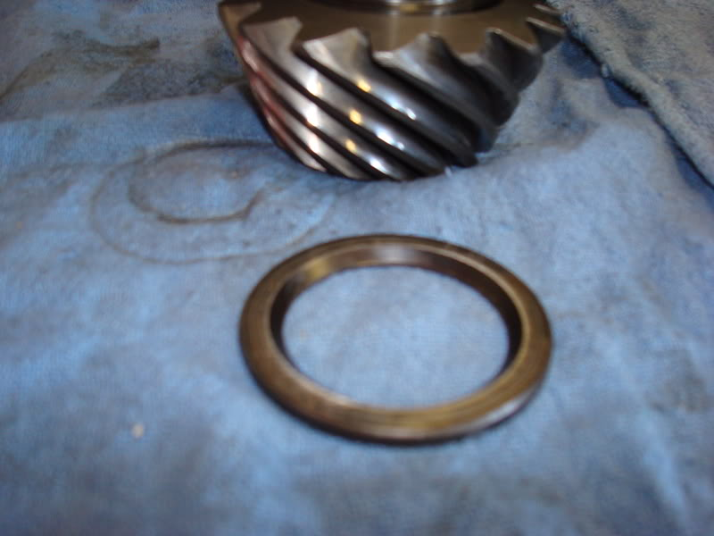
Place the shim on the pinion with the beveled end down and slide on a new big bearing.
You'll need a piece of pipe to drive the bearing on. Be sure its clean inside before starting. A hammer will do it, or use a press.
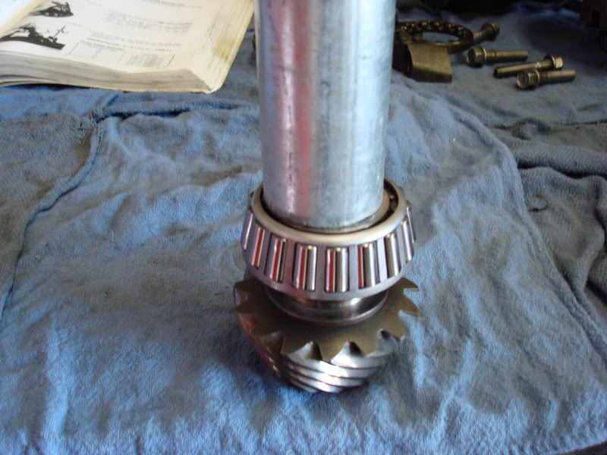
Now we have the crush sleeve. It helps you to get the pinion bearing preload correct by crushing down as you tighten the nut.
This makes things a lot easier since you don't have to install shims, measure and then install/replace shims again and again. It's a one-shot deal with these.
D-Code: 27171 Nomen: Piece, Distance: PN: 0305-27-171
The FSM does not say you HAVE to use a new sleeve every time, but its not a guarantee that the old one will work, so its best to use a new sleeve with a rebuild.
Slide that onto the pinion after the bearing is pressed on, then slide the whole thing into the 3rd member.
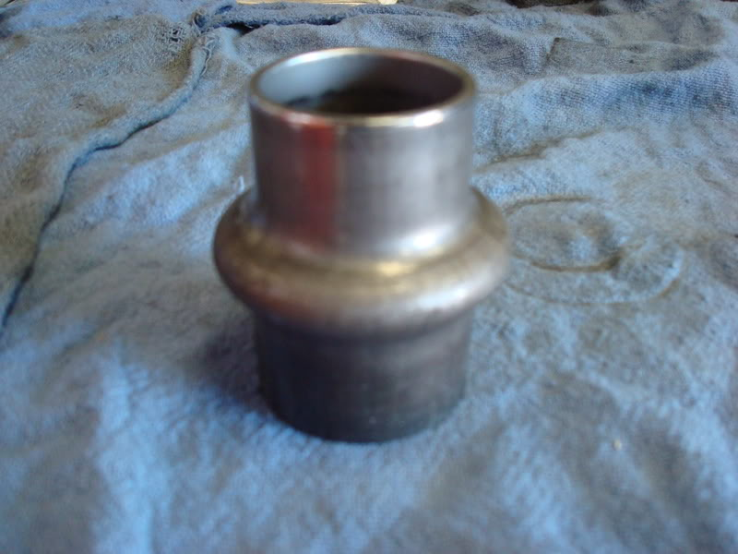
Next, from the front of the 3rd member, install the small pinion bearing and tap it down into contact with the crush sleeve.
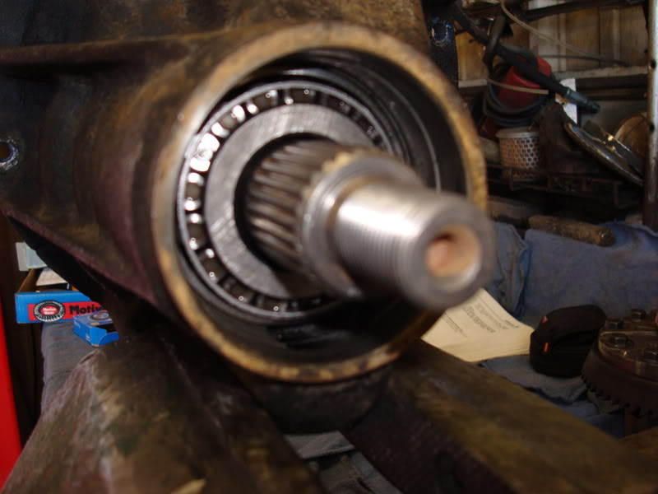
Install a new pinion oil seal and slide the companion flange into place. Don't worry that my seal and flange look different, I'm running a modified TII flange with a special seal since I have a large custom driveline. Install the washer and nut on a pinion threads and dab a little Loctite on the threads, especially if you reuse an old nut.
Tighten the nut just snug.....Just until it bottoms on the washer, but don't torque it yet.
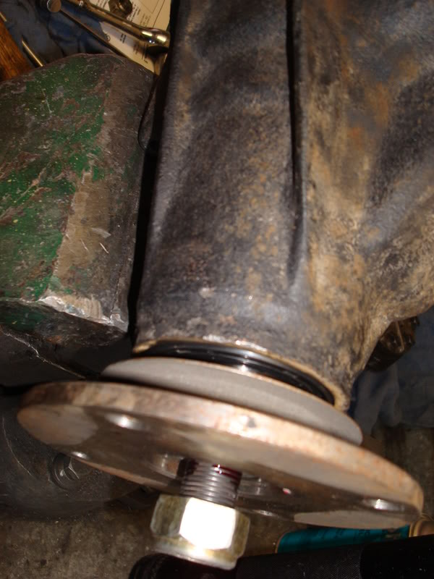
Now, we need to determine the oil seal drag so we can deduct that from the total bearing preload torque.
Lightly oil both bearings first, then use an in/lb. torque wrench and rotate the pinion, noting at what amount the pointer holds steady when turning.
Do not take the reading that shows when the wrench starts to turn, it will be higher than the actual reading while in motion. This is the torque needed to overcome the drag of the oil seal, mine was between 1-2 inch/lbs.
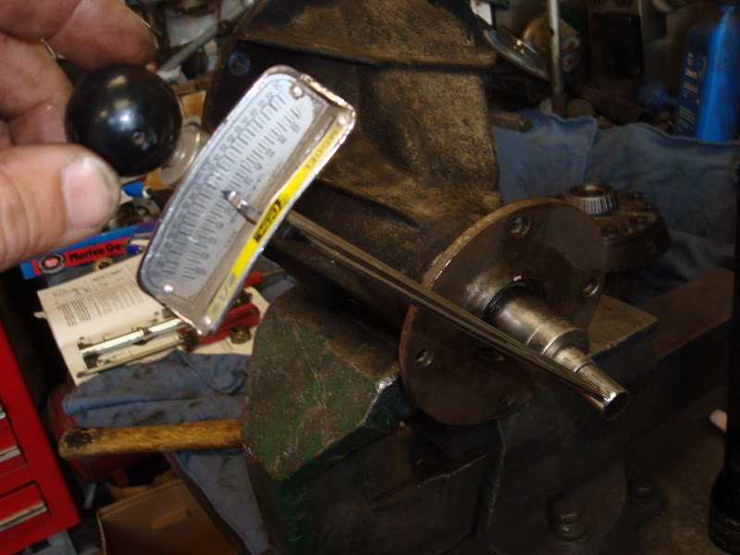
Now, we need to lock the pinion in place and torque the nut down to either crush the sleeve (if its new) or get some bearing preload into the pinions (if a used sleeve is installed). This is where you can get into trouble with an old sleeve, because you might bottom out the bearings before the races both contact the old, crushed sleeve. I used a couple short bolts and a long bar to hold the pinion. Don't be tempted to just jam a screw driver in the flange hole, it takes several hundred lbs. of force to crush a new sleeve and you will distort the flange, trust me.
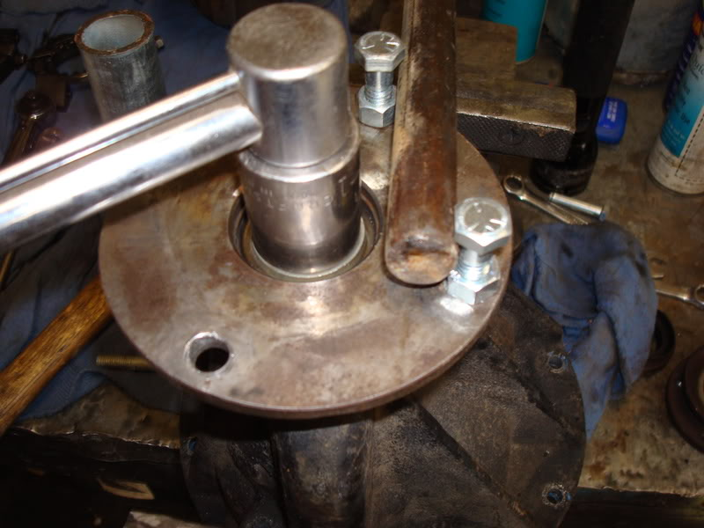
If you use an old sleeve, the pinion preload of 7.8-12.2 in/lbs....after deducting the oil seal drag..... must be reached before the nut reaches 130 lb./ft. of torque.
Also, if your preload exceeds 7.8-12.2 in/lbs. BEFORE the nut reaches 94 lb./ft., then you need a new sleeve. Its best to just get a new sleeve, its cheap.
Run the nut down until the "in-out" slop of the pinion starts to get down to zero. Once it gets down to nothing, limit your tightening to little tiny increments.....maybe 1/8" at a time. The bearing preload will increase exponentially once the bearings make contact with their races, and you don't want to over-do it. Take your inch-lb. torque wrench and keep checking the rotating preload of the pinion. It will take several nudges, but once it starts to get past 5 in/lbs., things will go fast so only tighten in SMALL amounts.
You want a pinion preload of between 7.8 and 12.2, not including the tiny amount you determined was the oil seal drag. I stopped right about 12in/lbs., minus the 1-2 in/lbs. of oil seal drag I got, and I'm sitting pretty at 10 in/lbs. of bearing preload. It feels tight, but its correct and will accommodate bearing wear as the diff gets used.
Also, once you get the pinion preload set, give both sides of the pinion a couple good taps with a hammer, then recheck the preload. The taps will ensure the bearings/races are fully seated and not cocked. I usually will have to go back and give her a little more torque after tapping the pinion and this time was no exception.....lost about 3-4 in/lbs. on my preload setting after the first round of taps, after that she held steady.
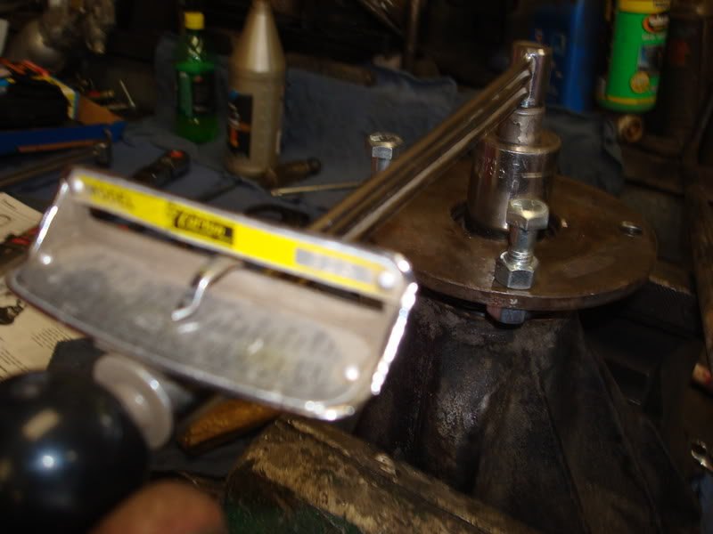
Now the pinion is fully installed, you can see why its not wise to change companion flanges or oil seals with the diff installed in the car. Its impossible to do all this setting up when the differential is fully assembled and its also pretty much a death sentence for the unit if the bearing preload is too tight/loose.
Now we need to install the carrier/led. First, make ABSOLUTELY sure the carrier is clean and flat where the ring gear slips on. Any dirt or dings in the carrier will mess things up and you'll be pulling your hair out later when the backlash settings will not pan out. File any burrs and clean both surfaces well. Be sure to tap the gear on with the holes lined up. If you have to wrench the first few bolts into place, then start over, they should go in with your fingers. Pushing them in to align the gear and carrier will cause the threads of the bolt to peel and the shavings will get under the gear and mess everything up. Once the holes are perfectly aligned, dab some Loctite on all the bolts and run them down in a crisscross pattern, stopping at 51-61 lb./ft. or torque.
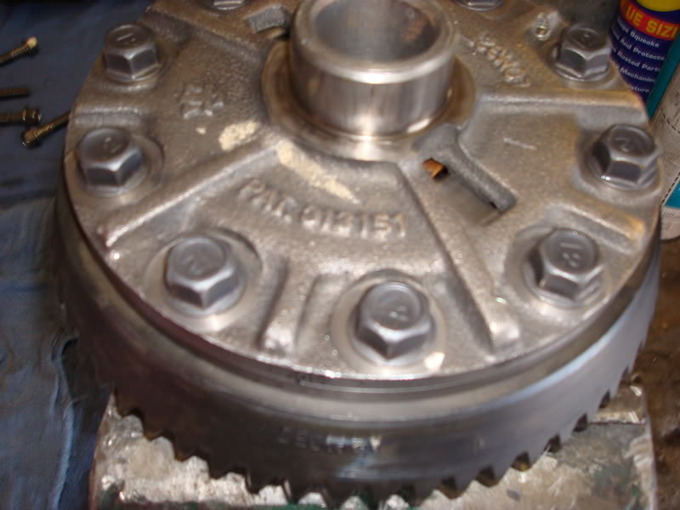
Now, install the new carrier bearings onto the carrier. You can press them or hammer them on, but don't use a socket to do it. I know, it seems like the perfect tool for it, but in addition to messing up your tools, you can contaminate the new bearings with chrome flakes from the socket. Use a piece of pipe or at least a plain steel impact socket. No shims are needed, so pre-clearanced "setup" bearings are not needed.....thank God!
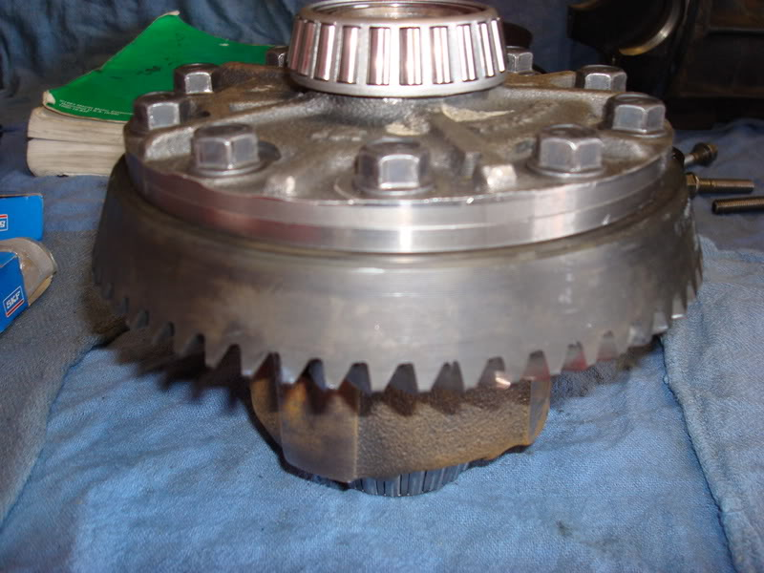
Now, set the carrier with its new bearings and outer races into the 3rd member and lightly oil the bearings.....we're almost done!
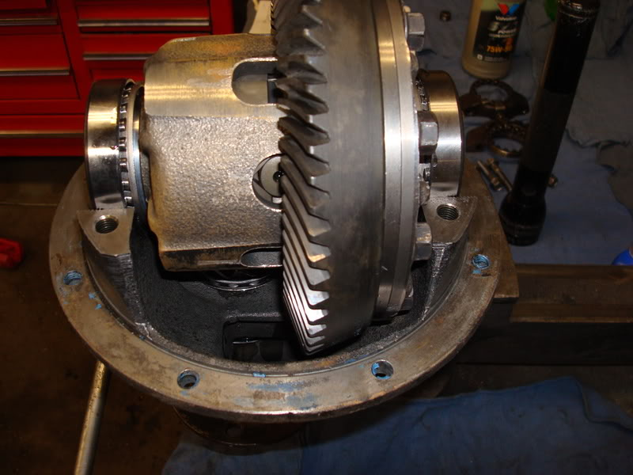
Slip the adjuster nuts into their grooves and spin them in against the bearing races until the bearing slop is gone. You'll want there to be a little tiny bit of gear backlash for now, but just do it by feel to get things close. Run the left adjuster out and the right adjuster in equal amounts to obtain more gear lash, and vise-versa to obtain less gear lash.
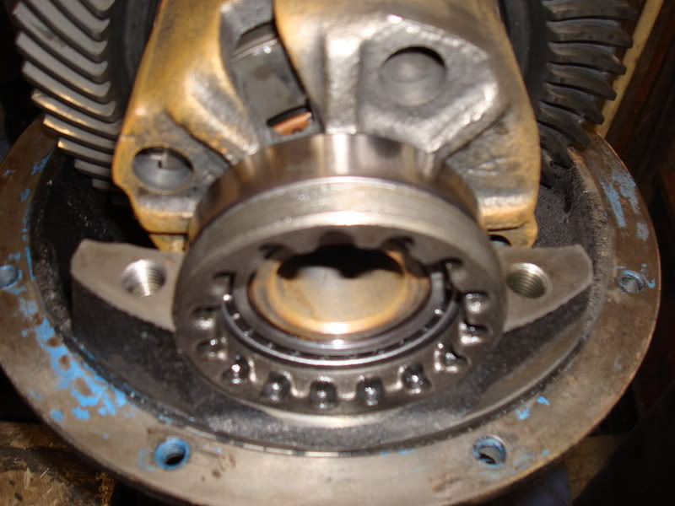
Now, install the bearing caps onto their saddles (you did mark them left and right earlier, correct?) and tighten the bolts just till they bottom, very loose for now.
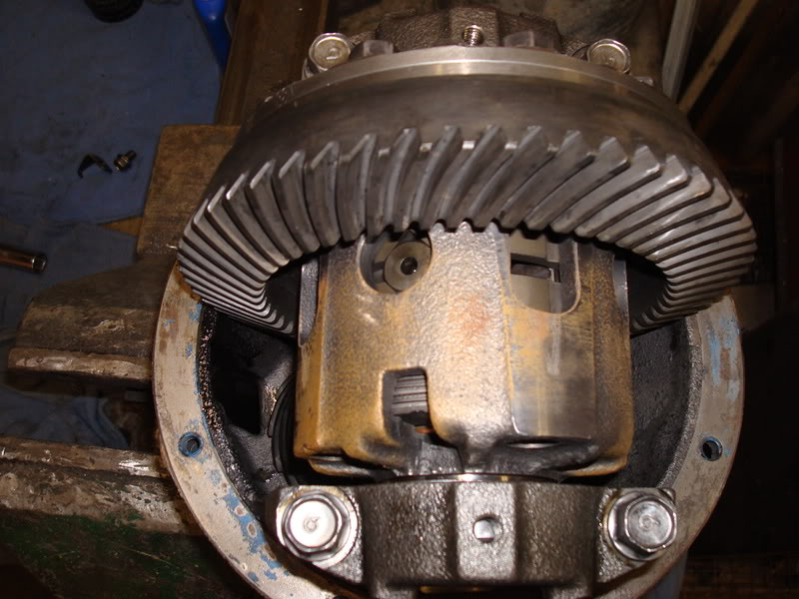
Set up your mag stand and dial indicator so that the pointer is touching the ring gear tooth at its very edge and so the pointer is in-line with the ring gear.
Mark the ring gear at 4 points, at roughly 90° spaces around the gear.
These are your measuring points. Rock the ring gear back and forth and measure the lash.
Your final setting is going to be .0035in - .0043in.....very tight lash compared to the big 4x4 stuff I'm used to, so be precise and certain as you check this setting.
Turn the adjusters in or out in equal amounts until you get this reading at all 4 points along the ring gear.
There can be variations, but the lowest reading must never be below .002in
and the spread between the highest and lowest reading must not exceed .0028in......so there's very little room for error. This is why the ring gear MUST sit flat on the carrier when you install it. There are proponents for going higher or lower within the allowable backlash settings. Some say a tighter backlash will compensate for deflection when the pinion pushes ring gear away under power. Some say a looser backlash will allow more oil to find its way between the gear teeth, better protecting them. Both camps are correct, so its up to you to decide which end of the range to set things. I got a nice .004in setting all around the ring gear, so I left things at that, right in the middle of the allowable tolerances.
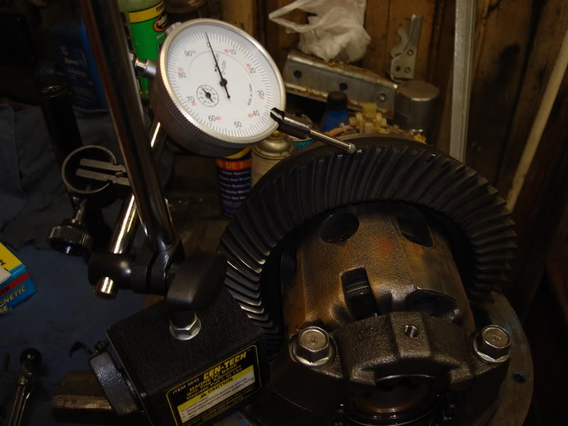
Now, tighten the two adjusters equally to set the carrier preload.
Be sure to rotate each adjuster equally so the lash doesn't change.
Its impossible to actually measure the carrier preload the way you check the pinion bearing preload since the diff unit is now assembled and the gear and pinion drag would mess things up. Yukon's gear guy says he's never had a failure due to excessive carrier bearing preload and it makes sense. The carrier bearings are turning at a leisurely pace, only 1/4 the speed of the pinion and they don't have to support any of the cars weight. Mazda has a spec for checking the value and it requires a large micrometer you use to take measurements at the little "nubs" on the bearings caps.
Measure diagonally across the diff to those 4 points and tighten the adjusters until both measurements are between 7.3004in - 7.30033in.
I took Yukon's advice and tightened the adjusters with a 12" tool I made. Its pretty easy to put together, I welded 2 small bolts to a bar, but you could easily drill and fasten the bolts if you don't have a welder. Center spacing for the bolts is 57MM and they will fit into the adjuster slots perfectly.
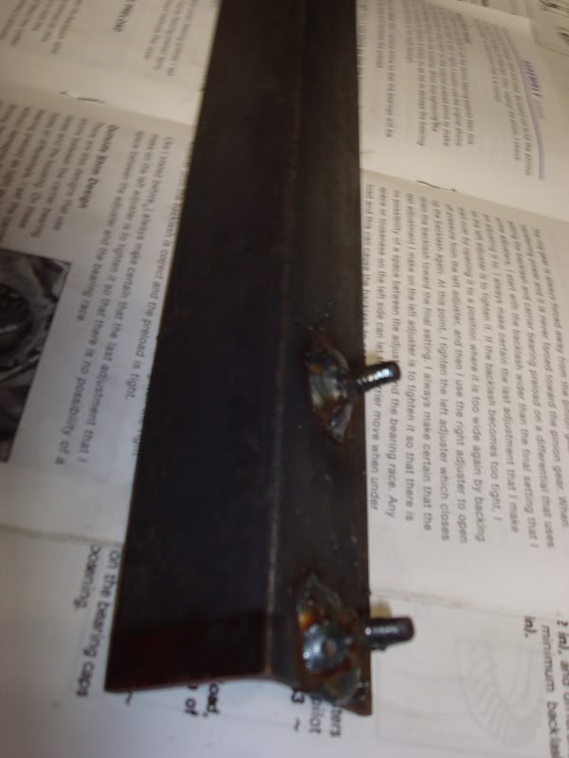
"Tight as you can reasonably get them with a 12" tool" is Yukon's recommendation.
Be sure the last adjustment you make is to tighten the left side adjuster in. This will insure that there is no slack between the left bearing and the left adjuster. The left bearing takes ALL the load of the pinion when the power is on, so you don't want to have it loose.
Once the carrier preload is set, tighten the bearing cap bolt to 27-38 ft./lb of torque.
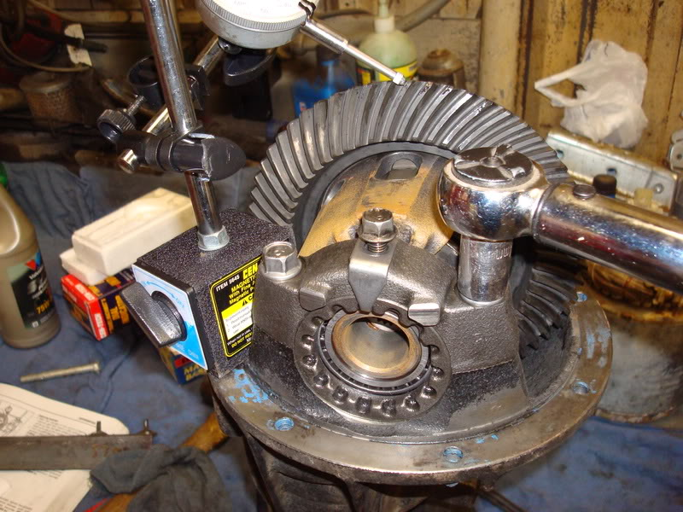
Install the locking tabs. You might have to alter the adjusters positions a tiny bit to get the slots lined up for the locks. The diff should feel pretty tight, but you should be able to turn it fairly easily with your hands.
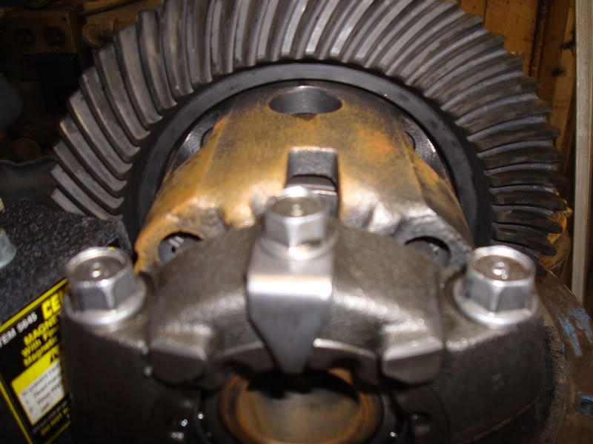
Once the caps are tight, go back and re-check the backlash one last time to be sure you didn't alter it when running the carrier bearing adjusters down.
Now its time to check the pattern, which should be dead on if you kept the right pinion shim for your housing. This part normally sucks, because you have to do it several times when selecting pinion shims for Dana and other style diffs. This type of system makes pattern setup a one-shot deal most of the time, if you keep the parts together from a given housing.
This is the only stuff to use. Forget about white grease, red lead or Prussian blue.......GM gear marking compound is THE BEST for setting gears and a $5 tube will last you a lifetime.
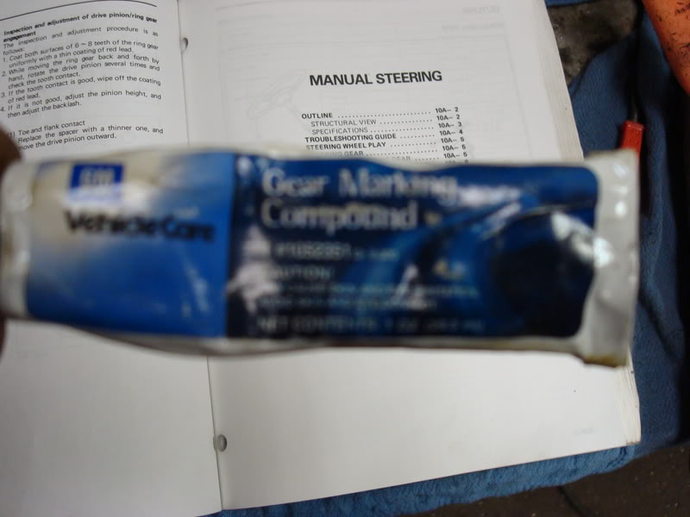
Coat a few teeth on both sides and repeat this at 3 or 4 points along the ring gear. I use a 3" bolt, tightened up in the companion flange to use as a crank to spin the pinion.
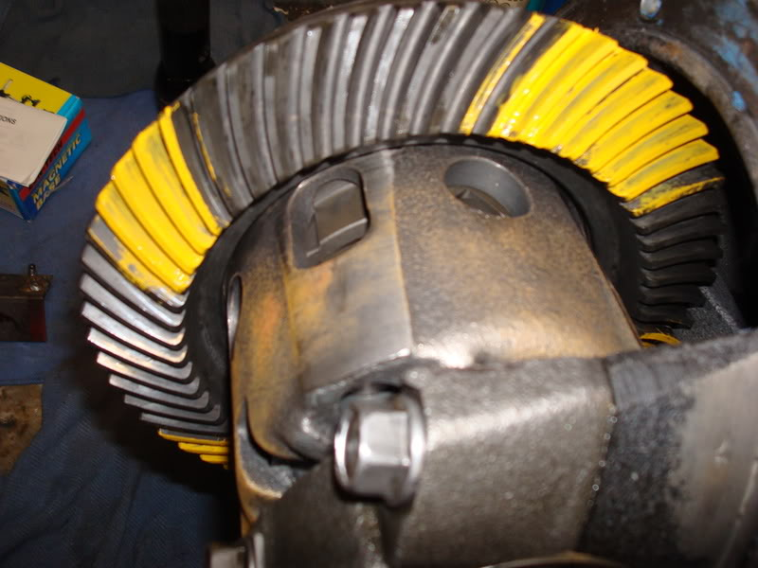
Use you right hand to crank the pinion and drag your left palm along the backside of the ring gear to provide some drag.
Spin the pinion both directions many times to get a good pattern built up on the drive and coast sides of the teeth.
You want the sliding action of the hypoid gears to rub away the compound where they mesh, allowing you to see where along the tooth the contact is being made.
The bare spot should always be in the middle of the tooth, relative to the base(flank) and tip (face) of the tooth.
There should always be some yellow left down at the bottom of each tooth and there should be at least a small line of yellow at the top.
The pattern should be centered front to back(heal and toe) on the tooth as well, but this is not always possible, and not 100% required.
I took several pics, but its a tough shot to get, so Ill only post the best ones.
It was dead on perfect the first time, on both the drive and coast sides of the teeth.
Sometimes its easier to see the pattern on the ring teeth you didn't coat with compound, since the stuff tends to get distributed on everything as the compound transfers to the pinion teeth and makes its way around the rest of the ring gear.
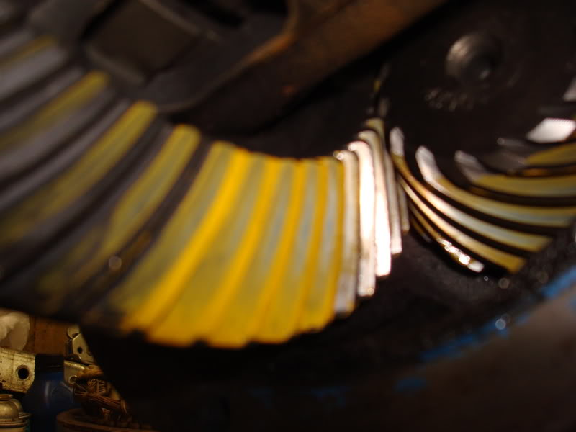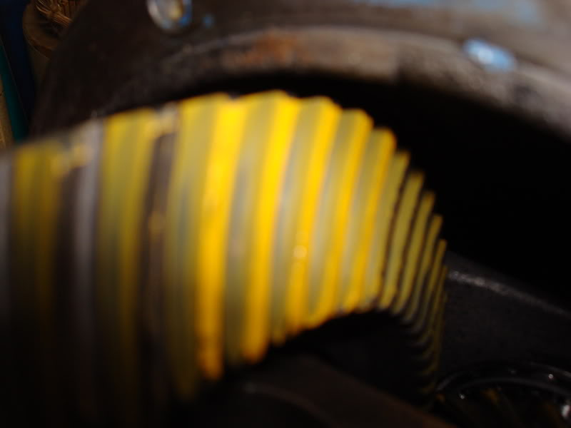
Its OK to leave the compound on the teeth, it will dissolve in the gear oil. Some say to wipe it off, but Id rather not risk getting towel or rag lint into my fresh rebuilt differential while trying to pick all the goop out of the teeth.....plus it gets everywhere, its like ultra-high pigment oil paint.
Well, that's it!!!!
If you are done, you can officially call yourself a gear head!
Just install and enjoy. My new 3.90 gears don't feel much different than the old 4.07 gears, but its hard to tell when the redline buzzer is screeching and the tires are breaking loose. I'd hoped the taller gears would help quell the traction loss issues, but it didn't. At least my MPG on the highway might go up 1/2 of a percent! And I have the piece of mind knowing that all my bearings are fresh and the LSD is working the best it possibly can. If anyone has any questions or comments regarding this job, feel free to ask.
For quick reference, additional info and good pattern setting knowledge, here's the link to Yukon's install guide, which I always carry with me when doing gears. There's no shame in using the manual, setting gears is a precise and critical job and only one who has been doing it a very long time, can say they can do it by "feel" or without instructions.
http://www.pirate4x4.com/tech/billav...structions.pdf
here's another good gear setup/diff. site.
http://www.gearinstalls.com/

3rd Member:
Carrier Bearing - Quantity 2: 0221-27-350
SKF 32008X - http://www.rockauto.com/en/moreinfo.php?pk=1840276&jsn=286 - $24.79
Pinion Front Bearing - Quantity 1: 0755-27-210
SKF BR32206 - http://www.rockauto.com/en/moreinfo.php?pk=1841602&jsn=290 - $16.75
Pinion Rear Bearing - Quantity 1: 0221-27-210
SKF BR32207 - http://www.rockauto.com/en/moreinfo.php?pk=1835402&jsn=276 - $30.79
Pinion Oil Seal - Quantity 1: M005-27-165
SKF 15849 - http://www.rockauto.com/en/moreinfo.php?pk=1836646&jsn=303 - $8.26
Crush Sleeve - Quantity 1 - "Piece Distance" 0305-27-171

Axle:
Axle Bearing - Quantity 2: 8595-26-151
https://www.atkinsrotary.com/store/84-85-Rx7-Rear-Wheel-Bearing-8595-26-151.html - $36.25
Axle Bearing Retainer - Quantity 2: 8545-26-152
BECK/ARNLEY 0530031 - http://www.rockauto.com/en/moreinfo.php?pk=494640&jsn=321 - $6.71
https://www.atkinsrotary.com/store/84-85-Rx7-Rear-Wheel-Bearing-Retainging-Collar-8545-26-152.html - $18.75
https://www.summitracing.com/parts/bck-053-0031 - $10.97
Axle Shaft Seal - Quantity 2: 1011-26-154
$6.00 - https://www.atkinsrotary.com/store/84-85-Rx7-Rear-Wheel-Bearing-Seal-1011-26-154.html
SKF 18862 - $6.58 / TIMKEN 224820 - $2.44
https://www.summitracing.com/parts/tmk-224820 - $4.97
Axle Bearing Spacer - Quantity 2: FA66-26-155
$10.77 https://www.parts.com/index.cfm?fuseaction=store.PartInfo&PartNumber=FA6626155&VehicleID=181993&diagram=F693120&Title%3D-RX7-SPACER
$16.25
https://www.atkinsrotary.com/store/84-85-Rx7-Rear-Wheel-Bearing-Spacer-FA66-26-155.html

